

**HOLY INTERNATIONAL SR. SEC. SCHOOL**

**COMPUTER SCIENCE – PYTHON**

**SUBJECT CODE – 083**

**CLASS XII**

**SESSION 2021 – 22**

**PROJECT FILE**

**TERM - II**



**NAME : CHIRAG CHAUHAN**

**BOARD ROLL NO. :**

**TEACHER’S SIGNATURE :**

***INDEX***



|  |  |  |
| --- | --- | --- |
| S.NO. | CONTENT | PAGE NO |
| 1 | CERTIFICATE | 3 |
| 2 | ACKWONLEDGEMENT | 4 |
| 3 | INTRODUCTION TO PROJECT | 5 |
| 4 | OBJECTIVE AND SCOPE OF THE PROJECT | 6 |
| 5 | BASIC FUNCTIONALITIES | 7 |
| 6 | TIME MANAGEMENT | 8 |
| 7 | SOFTWARE AND HARDWARE USED | 9 |
| 8 | DATABASE DICTIONARY | 10 |
| 9 | DATTA FILE (CSV) | 11 - 15 |
| 10 | SOURCE CODE | 16 - 25 |
| 11 | OUTPUT | 26 - 37 |
| 12 | AREAS OF IMPROVEMENT, FUTURE SCOPE AND FURTHER ENHANCEMENTS | 38 |
| 13 | CONCLUSION | 39 |
| 14 | BIBLIOGRAPHY AND REFRENCES | 40 |



***certificate***

This to certify that **CHIRAG CHAUHAN** of class XII of

**HOLY INTERNATIONAL SR. SEC. SCHOOL** has completed his

project file under my guidance. He has taken proper care and

showing utmost sincerity in completing his project. It verifies

that this project is up to my expectation and as per the

guidance issued by CBSE.



***ACKWONLEDGEMENT***

It is with great pleasure that I find myself planning down these lines to express my sincere thanks to all those who helped me a long way in completing this project. The harmonious climate in our school provide proper atmosphere for preparing the project. It was privileged to have been guided by **Ms. SURBH JOHRI**. I am also grateful to my classmate who helped during the finalization of the project with their constructive advice.

**NAME : CHIRAG CHAUHAN**

**ROLL NO. :**

**DATE :**

***INTRODUCTION***

***TO***

***COVID-19 24X7 HELPLINE SYSTEM***

Welcome to COVID-19 24X7 HELPLINE SYSTEM. This project

is for many purposes because. I want to give full satisfaction

of the user.

In my project I provide many facilities to user. COVID-19

24X7 HELPLINE SYSTEM. It is very difficult to manage

all things but with the help of my software it becomes

very easy to handle .It saves our time and paper work.

So we consider the above problem and make this software.

In this software you store all kinds of information



***OBJECTIVE AND SCOPE OF THE PROJECT***

Our consideration while developing this software was to achieve the following goals:-

1. This software is for COVID -19 24X7 HELPLINE SYSTEM so it provides those facilities, which is used in any hospital, personal computer user.
2. It also saves valuable time of the patient and lots of paper work.
3. This will saves lots of effort of the user. Anyone is able to manage lots of information after using this software and also able for seeing in different angles.
4. User can manage all the records very easily. You can manage all the records very easily. You can generate all kinds of reports like Beds availability, oxygen availability with respect of Zone, State, and City.
5. In Zone, we have used the data north, south, east, west, south east, central, north west, south west, north east**.**
6. In city we have used the data New Delhi, Noida and Gurugram.
7. In state we have used the data Delhi, U.P ad Haryana in which we have used only Gurugram data from Haryana and Noida data from Uttar Pradesh (U.P) and whole Delhi data including all zones.



***BASIC FUNCTIONALITIES***

It perform the basic functionality which are as follows:-

1. We have stored the basic patient details in **“data.csv”** and it is compulsory to enter the patient’s details in the starting and then as user can go for further options.
2. We have also created the csv file for storing the details of Oxygen and Beds availability which termed as **“oxygen.csv”** in which we stored the hospital data according to their location, zone, state or city wise.
3. Zone include East, West, North, South, North-West, North-East, South-West and South-East for all the states which we have included. State include Delhi, Haryana, and Uttar Pradesh (U.P) from these states we have chosen the Cities which are New Delhi, Gurugram from Haryana state, and Noida from U.P state.



***TIME MANAGEMENT***

***4 Days***

Creation of Rough Design of Project

Performance Testing

Documentation

Programming

Database Connectivity

Code Testing

User Testing

***2 Days***

***3 Days***

***4 Days***

***2 Days***

***20 Days***

***5 Days***



***SOFTWARE AND HARDWARE USED***

|  |  |
| --- | --- |
| SOFTWARE USED | |
| PYTHON 3.9 | SOFTWARE DEVELOPMENT |
| MS OFFICE EXCEL | DATABASE (CSV FILE) |

|  |  |
| --- | --- |
| HARDWARE USED | |
| PROCESSOR | INTEL CORE i3 |
| RAM | 4 GB (giga byte) |
| SYSTEM TYPE | 64 BIT |
| CPU | @ 2.10GHz 2.59 GHz |
| STORAGE | 1TB (TERA BYTE) |



***DATABASE DICTIONARY***

We have used two CSV (Comma Separate Value) files for storing the data and retrieval of the data whose working is given below:-

1. Firstly, we have created **“data.csv”** whichstores the basic patient details and it is compulsory to enter the patient’s details in the starting and then as user can go for further options.
2. Secondly, We have created the another csv file for storing the details of Oxygen and Beds availability which is known as **“oxygen.csv”** in which we stored the hospital data according to their location, zone, state or city wise and Zone include East, West, North, South, North-West, North-East, South-West and South-East for all the states which we have included. State include Delhi, Haryana, and Uttar Pradesh (U.P) from these states we have chosen the Cities which are New Delhi, Gurugram from Haryana state, and Noida from U.P state.





DATA FILE

(CSV)

**Data.csv**

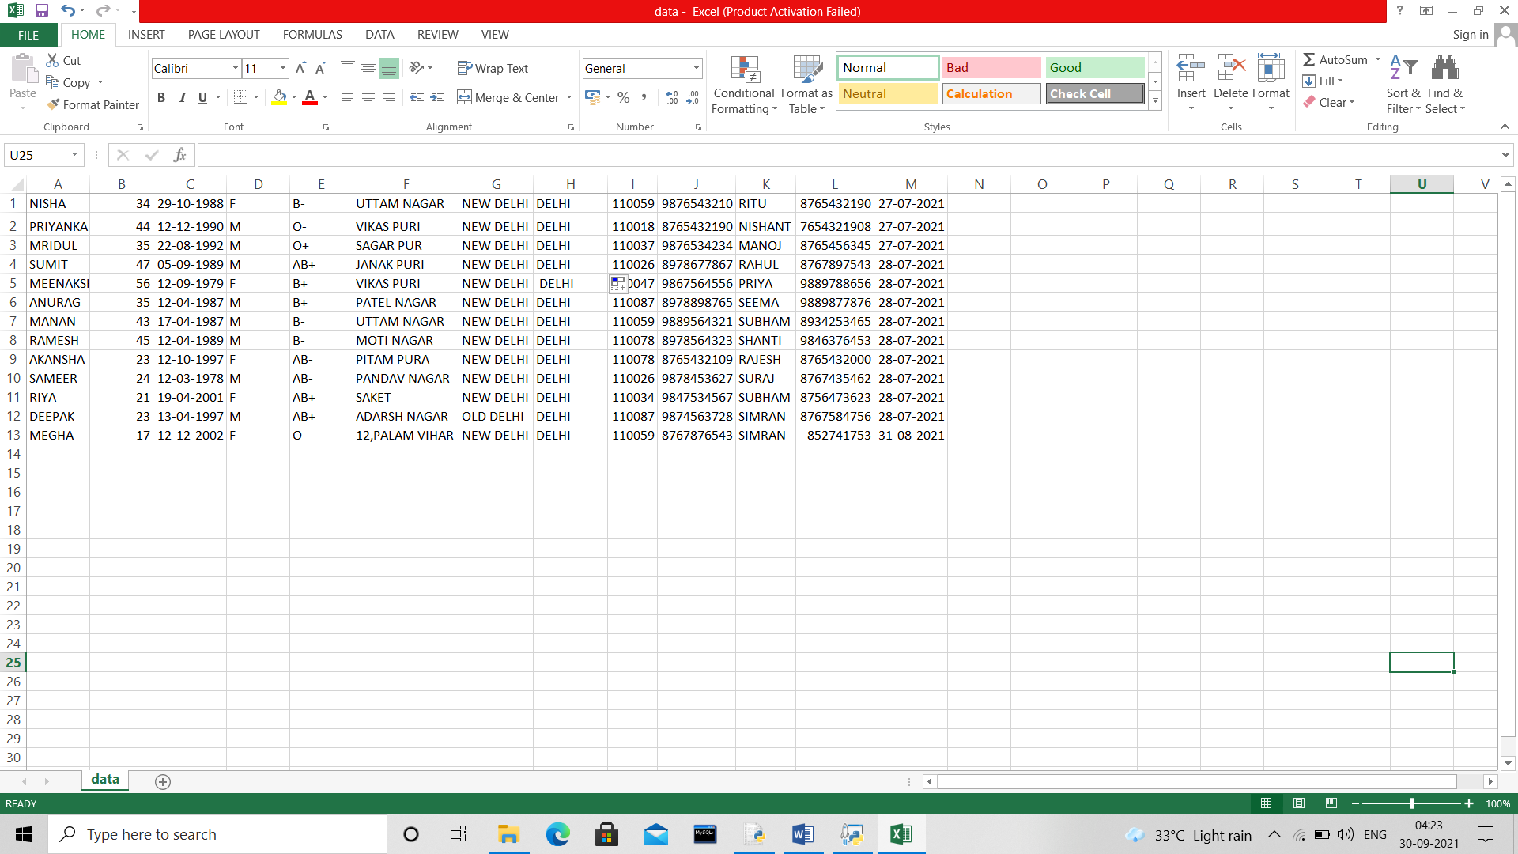

**Oxygen.csv**

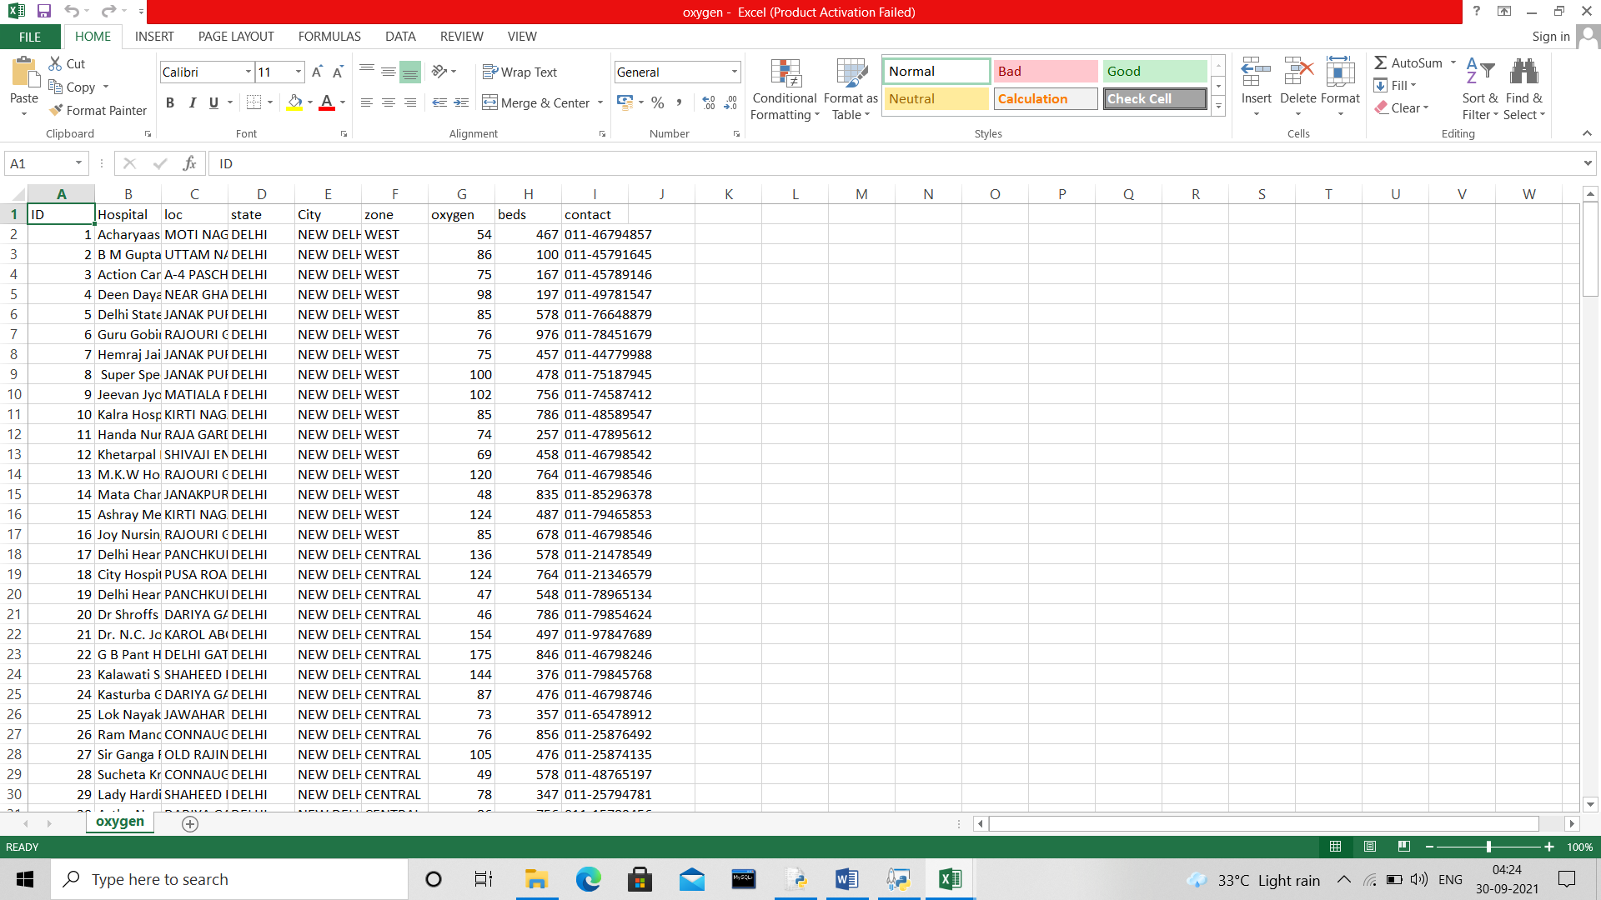

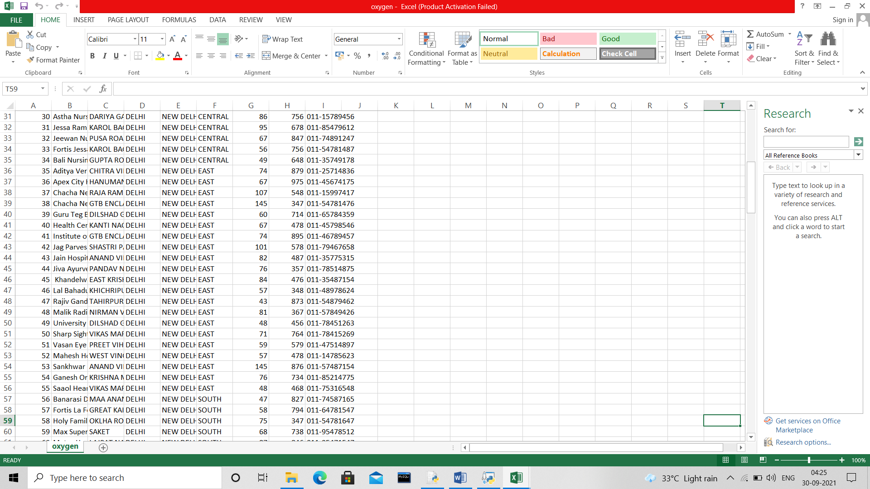

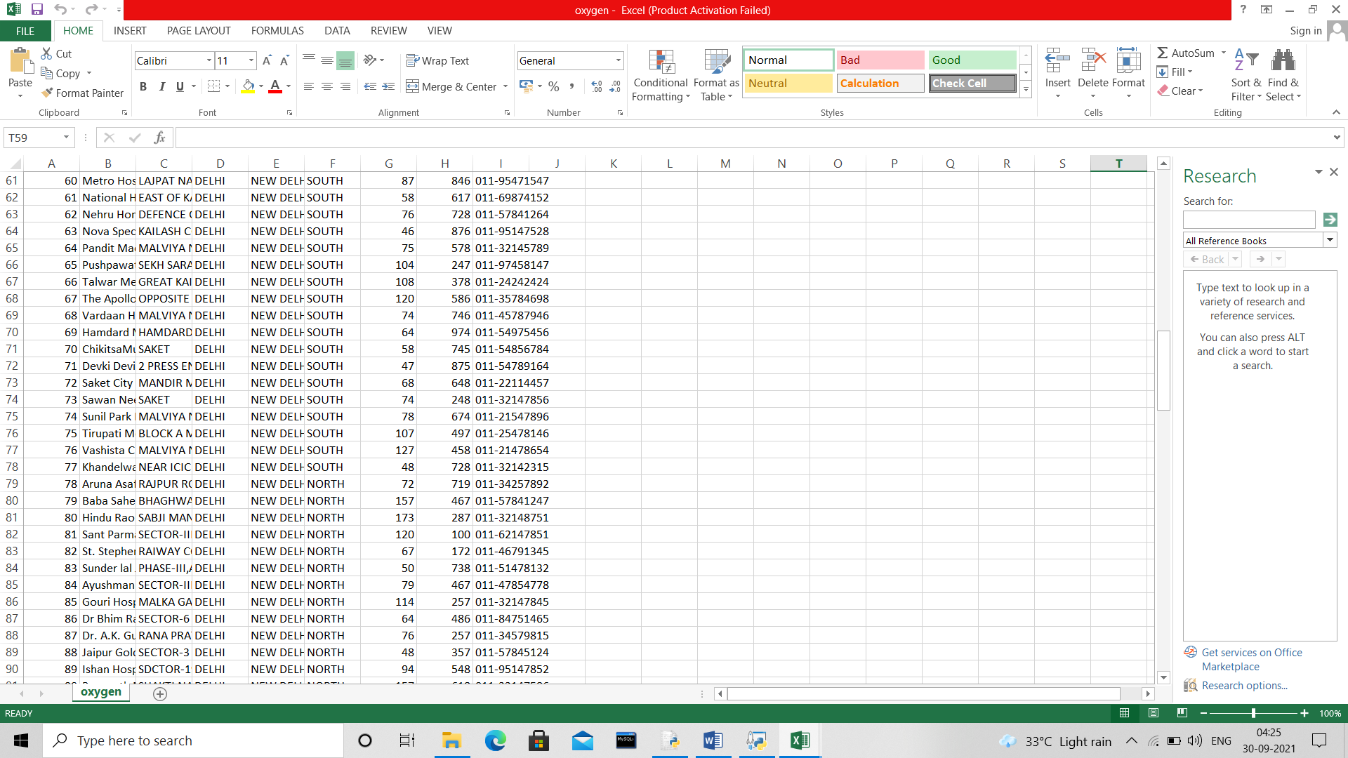

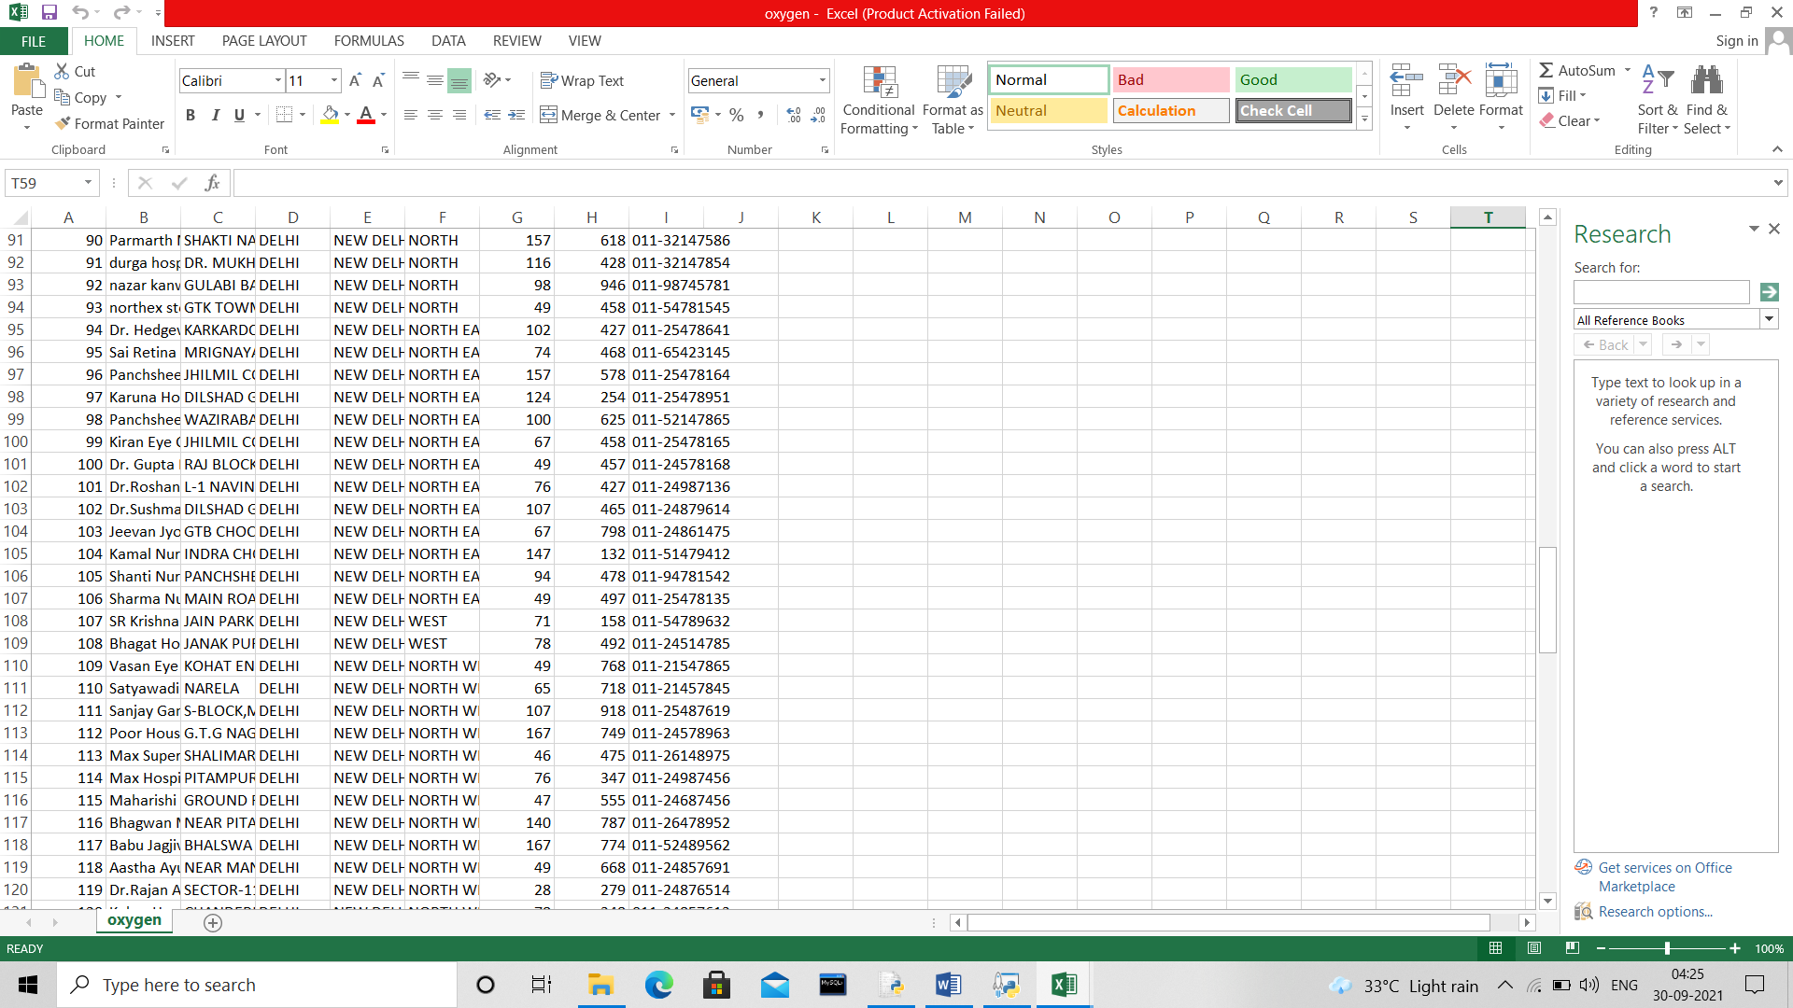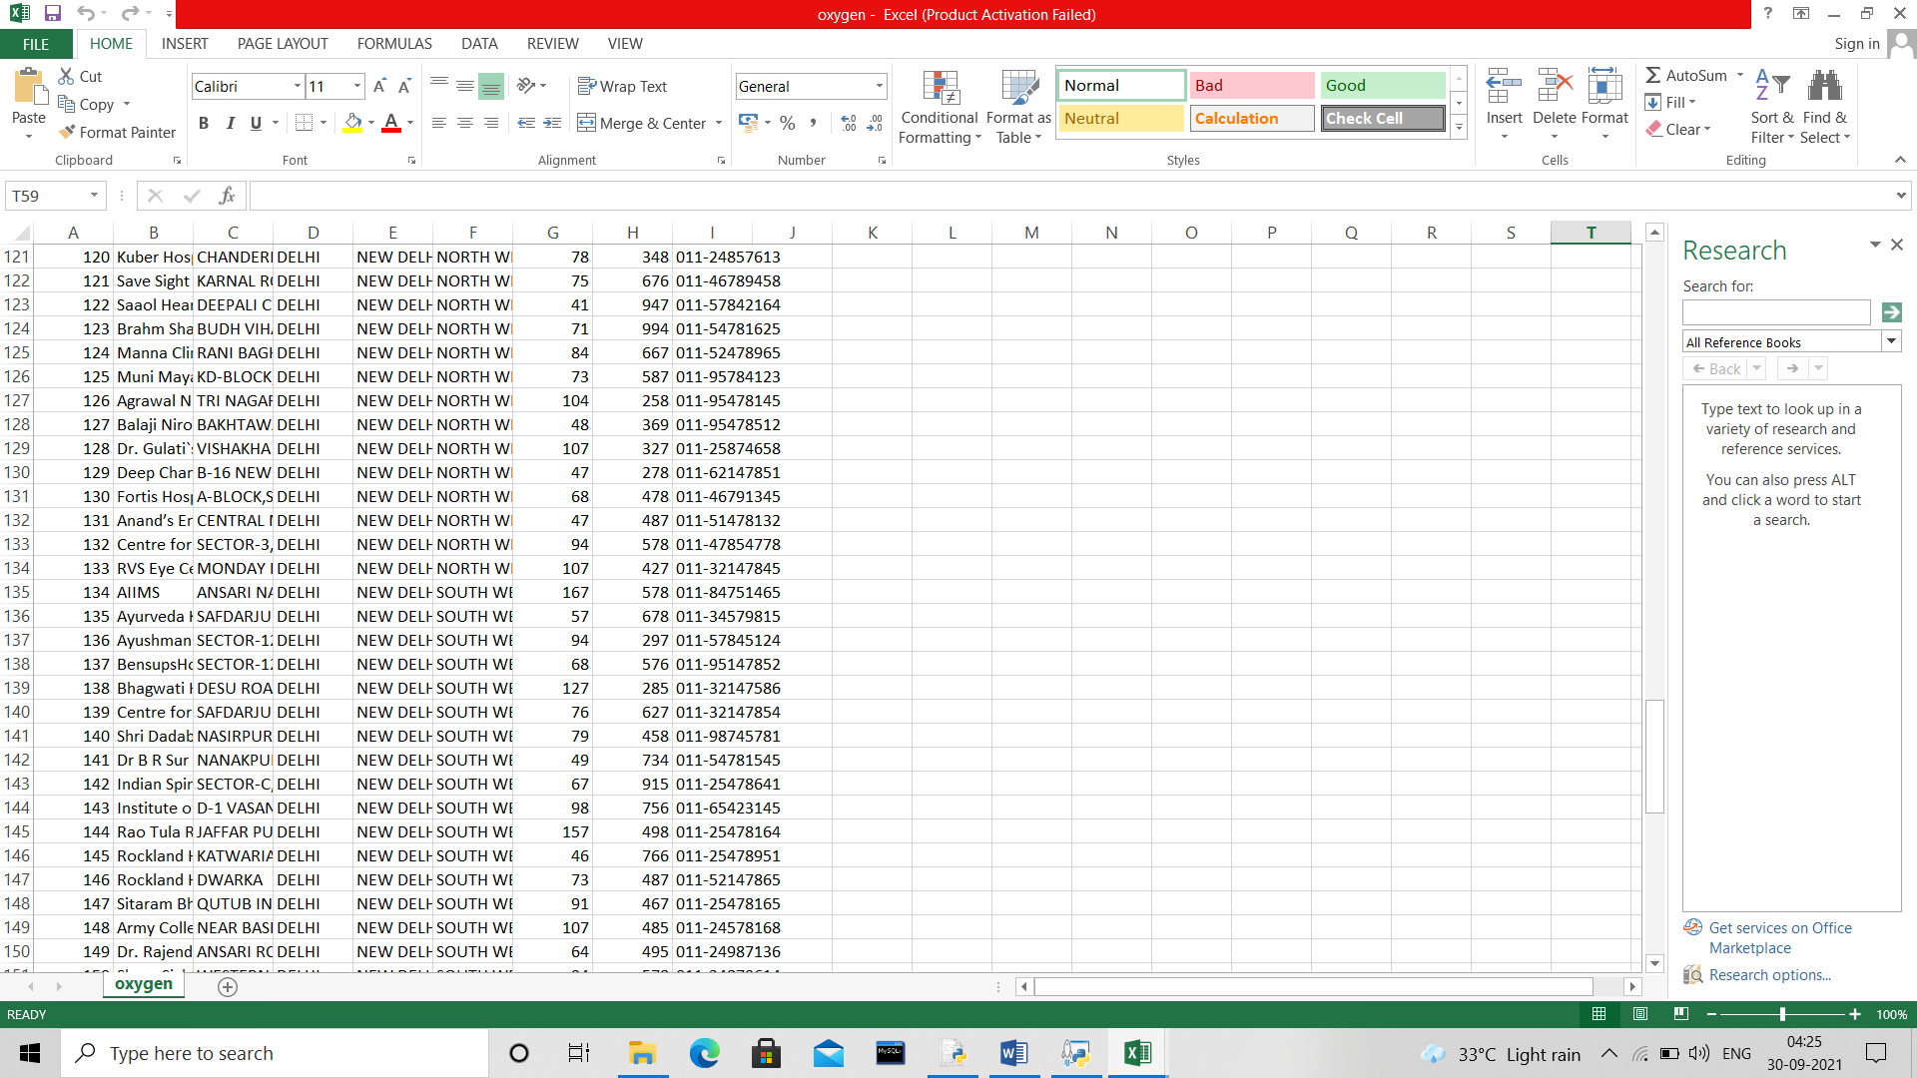

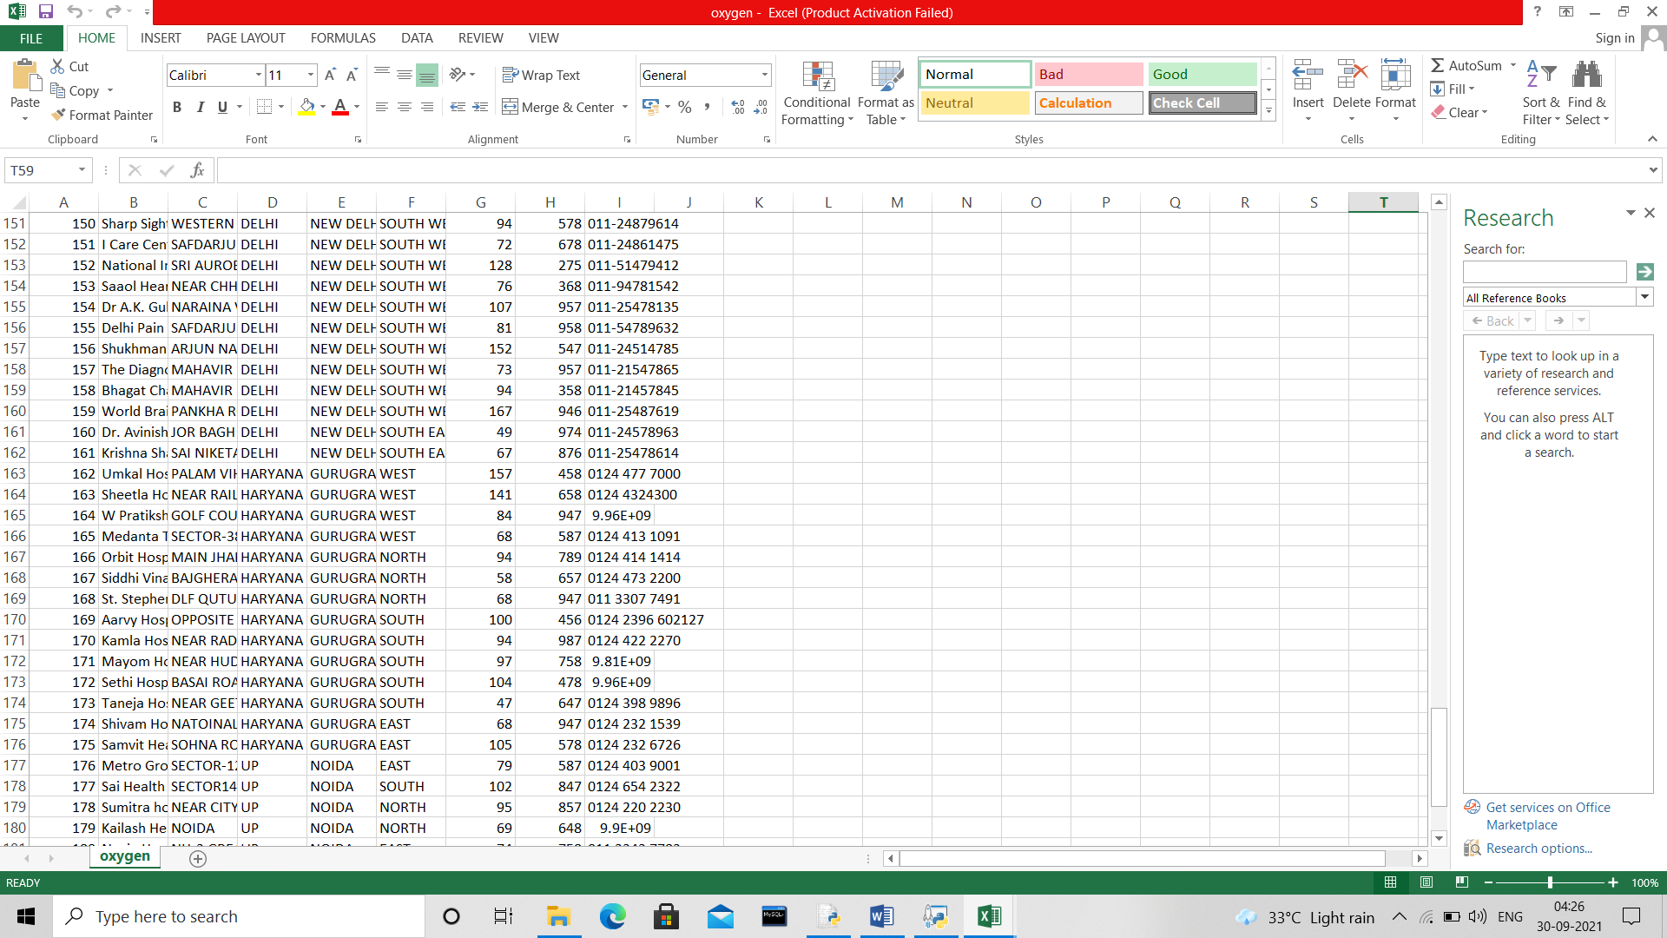

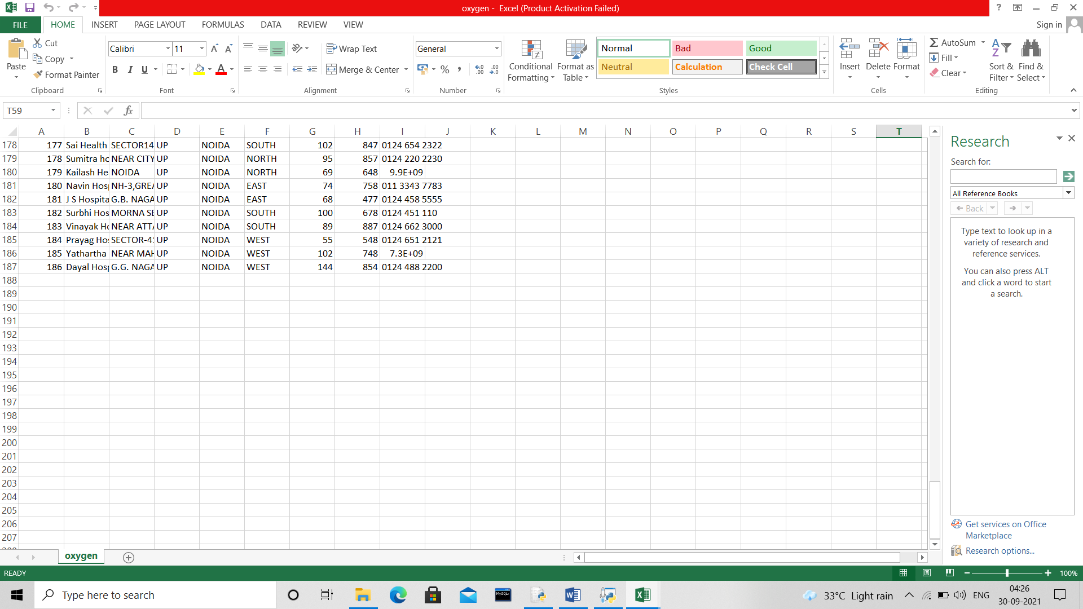



SOURCE

CODE

**Main.py**

import csv

import sys

'''import patient

patient.patientinfo()'''

#second menu started

while(1):

print('''

----------------------------------------------------------------------------------------------------

| CHOOSE YOUR OPTION |

| 1. COVID - 19 TEST |

| 2. BEDS AVAILABILITY |

| 3. OXYGEN AVAILABILITY |

| 4. EXIT |

----------------------------------------------------------------------------------------------------

''')

ch=int(input("Enter Your Choice \t:\t"))

if ch==1: #covid test

print('''

----------------------------------------------------------------------------------------------------

>>>>>>>>>>>>>>>>>>>>>>>>>>>>>>>>>>>> COVID - 19 TEST <<<<<<<<<<<<<<<<<<<<<<<<<<<<<<<<<<<<<<<

----------------------------------------------------------------------------------------------------

''')

print("CHOOSE THE SYMPTOMS IN RESPECT OF YES / NO WHICH YOU HAVE ")

count=0

s1=input("1. FEVER(Y/N)\t\t\t\t:\t")

s2=input("2. DRY COUGH(Y/N)\t\t\t:\t")

s3=input("3. TIREDNESS(Y/N)\t\t\t:\t")

s4=input("4. ACHES AND PAINS(Y/N)\t\t\t:\t")

s5=input("5. SORE THROAT(Y/N)\t\t\t:\t")

s6=input("6. DIARHOEA(Y/N)\t\t\t:\t")

s7=input("7. HEADACHE(Y/N)\t\t\t:\t")

s8=input("8. LOSS OF TASTE AND SMELL(Y/N)\t\t:\t")

s9=input("9. A RASH ON SKIN(Y/N)\t\t\t:\t")

s10=input("10. DIFFICULTY IN BREATHING(Y/N)\t:\t")

s11=input("11. CHEST PAIN OR PRESSURE(Y/N)\t\t:\t")

s12=input("12. LOSS OF SPEECH OR MOVEMENT(Y/N)\t:\t")

if s1=="Y" or s1=="y" :

count+=1

if s2=="Y" or s2=="y":

count+=1

if s3=="Y" or s3=="y":

count+=1

if s4=="Y" or s4=="y":

count+=1

if s5=="Y" or s5=="y":

count+=1

if s6=="Y" or s6=="y":

count+=1

if s7=="Y" or s7=="y" :

count+=1

if s8=="Y" or s8=="y":

count+=1

if s9=="Y" or s9=="y":

count+=1

if s10=="Y" or s10=="y":

count+=1

if s11=="Y" or s11=="y":

count+=1

if s12=="Y" or s12=="y":

count+=1

print("--------------------------------------------------------")

print("\n\nTotal no. of symptoms counted positive\t:\t",count)

print("--------------------------------------------------------")

if count>=10:

print("\nYou are highly infected with the following symptoms which you have entered as Yes, Consult a doctor and take proper treatment according to your symptoms.")

elif count>=8:

print("\nYou are mildly infected with the following symptoms which you have entered as Yes, Consult a doctor and take proper treatment according to your symptoms.")

elif count>=5:

print("\nFound Positive according to the manual test. Take precautions and maintain distance from others.")

else :

print("\nCongratulations!! You found negative")

elif ch==2: #checking of beds availability

print('''

----------------------------------------------------------------------------------------------------

>>>>>>>>>>>>>>>>>>>>>>>>>>>>>>>>>>>> BEDS AVAILABILITY <<<<<<<<<<<<<<<<<<<<<<<<<<<<<<<<<<<<<<<

----------------------------------------------------------------------------------------------------

''')

with open('oxygen.csv', 'r') as file:

my_reader = csv.reader(file, delimiter=',')

'''for row in my_reader:

print()'''

while(1):

print("""

~~~~~~~~~~~~~~~~~~~~~~~~~~~~~~~~~~~~~~~~~~~~~~~~~~~~~~~~~~~~~~~~~~~~~~~~~~~~~~~~~~~~~~~~~~~~~~~~~~~~

----------------- PLEASE SELECT THE APPROPRIATE OPTION TO SEARCH THE BEDS AVAILABILITY -------------

~~~~~~~~~~~~~~~~~~~~~~~~~~~~~~~~~~~~~~~~~~~~~~~~~~~~~~~~~~~~~~~~~~~~~~~~~~~~~~~~~~~~~~~~~~~~~~~~~~~~

1. ZONE WISE

2. CITY WISE

3. STATE WISE

4. EXIT

~~~~~~~~~~~~~~~~~~~~~~~~~~~~~~~~~~~~~~~~~~~~~~~~~~~~~~~~~~~~~~~~~~~~~~~~~~~~~~~~~~~~~~~~~~~~~~~~~~~~

""")

N=int(input("Choose your option (1-4)\t:\t"))

if N==1 :

print('''

----------------------

ZONES AVAILABLE

----------------------

EAST

WEST

NORTH

SOUTH

CENTRAL

NORTH EAST

NORTH WEST

SOUTH EAST

SOUTH WEST

----------------------

''')

zone = input("Enter Zone\t:\t")

csv_file = csv.reader(open('oxygen.csv', "r"), delimiter=",")

#loop through the csv list

print("@@@@@@@@@@@@@@@@@@@@@@@@@@@@@@@@@@@@@@@@@@@@@@@@@@@@@@@@@@@@@@@@@@@@@@@@@@@@@@@@@@@@@@@@@@@@@@@@@@@@")

print("\t\t",zone.upper(),"ZONE HOSPITAL NAME AND THEIR BEDS AVAILABLE")

print("@@@@@@@@@@@@@@@@@@@@@@@@@@@@@@@@@@@@@@@@@@@@@@@@@@@@@@@@@@@@@@@@@@@@@@@@@@@@@@@@@@@@@@@@@@@@@@@@@@@@")

for row in csv_file:

#if current rows 2nd value is equal to input, print that row

if zone.upper() == row[5]:

print("Hospital Name \t\t:\t",row[1])

print("Location \t\t:\t",row[4])

print("Beds Availability \t:\t",row[7])

print("Contact No. \t\t:\t",row[8])

print("----------------------------------------------------------------------------------------------------")

break

elif N==2:

print('''

CITY AVAILABLE

------------------------

NEW DELHI

NOIDA

GURUGRAM

------------------------''')

City = input("Enter City\t:\t")

csv_file = csv.reader(open('oxygen.csv', "r"), delimiter=",")

#loop through the csv list

print("@@@@@@@@@@@@@@@@@@@@@@@@@@@@@@@@@@@@@@@@@@@@@@@@@@@@@@@@@@@@@@@@@@@@@@@@@@@@@@@@@@@@@@@@@@@@@@@@@@@@")

print("\t\t",City.upper(),"CITY HOSPITAL NAME AND THEIR BEDS AVAILABLE")

print("@@@@@@@@@@@@@@@@@@@@@@@@@@@@@@@@@@@@@@@@@@@@@@@@@@@@@@@@@@@@@@@@@@@@@@@@@@@@@@@@@@@@@@@@@@@@@@@@@@@@")

for row in csv_file:

#if current rows 2nd value is equal to input, print that row

if City.upper() == row[4]:

print("Hospital Name \t\t:\t",row[1])

print("Beds Availability \t:\t",row[7])

print("Contact No. \t\t:\t",row[8])

print("----------------------------------------------------------------------------------------------------")

break

elif N==3:

print('''

STATE AVAILABLE

------------------------

DELHI

HARYANA

UP

------------------------''')

state = input("Enter State\t:\t")

csv_file = csv.reader(open('oxygen.csv', "r"), delimiter=",")

#loop through the csv list

print("@@@@@@@@@@@@@@@@@@@@@@@@@@@@@@@@@@@@@@@@@@@@@@@@@@@@@@@@@@@@@@@@@@@@@@@@@@@@@@@@@@@@@@@@@@@@@@@@@@@@")

print("\t\t",state.upper(),"STATE HOSPITAL NAME AND THEIR BEDS AVAILABLE")

print("@@@@@@@@@@@@@@@@@@@@@@@@@@@@@@@@@@@@@@@@@@@@@@@@@@@@@@@@@@@@@@@@@@@@@@@@@@@@@@@@@@@@@@@@@@@@@@@@@@@@")

for row in csv_file:

#if current rows 2nd value is equal to input, print that row

if state.upper() == row[3]:

print("Hospital Name \t\t:\t",row[1])

print("Beds Availability \t:\t",row[7])

print("Contact No. \t\t:\t",row[8])

print("----------------------------------------------------------------------------------------------------")

break

elif ch==4: #exit from menu

break

else:

print("You have entered an invalid choice. Please enter a valid choice (1-4)")

elif ch==3: #checking of oxygen availability

print('''

----------------------------------------------------------------------------------------------------

>>>>>>>>>>>>>>>>>>>>>>>>>>>>>>>>>>>> OXYGEN AVAILABILITY <<<<<<<<<<<<<<<<<<<<<<<<<<<<<<<<<<<<<<

----------------------------------------------------------------------------------------------------

''')

with open('oxygen.csv', 'r') as file:

my_reader = csv.reader(file, delimiter=',')

'''for row in my_reader:

print(row)'''

while(1):

print("""

~~~~~~~~~~~~~~~~~~~~~~~~~~~~~~~~~~~~~~~~~~~~~~~~~~~~~~~~~~~~~~~~~~~~~~~~~~~~~~~~~~~~~~~~~~~~~~~~~~~~

--------------- PLEASE SELECT THE APPROPRIATE OPTION TO SEARCH THE OXYGEN AVAILABILITY -------------

~~~~~~~~~~~~~~~~~~~~~~~~~~~~~~~~~~~~~~~~~~~~~~~~~~~~~~~~~~~~~~~~~~~~~~~~~~~~~~~~~~~~~~~~~~~~~~~~~~~~

1. ZONE WISE

2. CITY WISE

3. STATE WISE

4. EXIT

~~~~~~~~~~~~~~~~~~~~~~~~~~~~~~~~~~~~~~~~~~~~~~~~~~~~~~~~~~~~~~~~~~~~~~~~~~~~~~~~~~~~~~~~~~~~~~~~~~~~

""")

N=int(input("Choose your option (1-4)\t:\t"))

if N==1 :

print('''

----------------------

ZONES AVAILABLE

----------------------

EAST

WEST

NORTH

SOUTH

CENTRAL

NORTH EAST

NORTH WEST

SOUTH EAST

SOUTH WEST

----------------------

''')

zone = input("Enter Zone\t:\t")

csv_file = csv.reader(open('oxygen.csv', "r"), delimiter=",")

#loop through the csv list

print("@@@@@@@@@@@@@@@@@@@@@@@@@@@@@@@@@@@@@@@@@@@@@@@@@@@@@@@@@@@@@@@@@@@@@@@@@@@@@@@@@@@@@@@@@@@@@@@@@@@@")

print("\t\t",zone.upper(),"ZONE HOSPITAL NAME AND THEIR OXYGEN AVAILABLE")

print("@@@@@@@@@@@@@@@@@@@@@@@@@@@@@@@@@@@@@@@@@@@@@

@@@@@@@@@@@@@@@@@@@@@@@@@@@@@@@@@@@@@@@@@@@@@@@@@@@@@@@")

for row in csv_file:

#if current rows 2nd value is equal to input, print that row

if zone.upper() == row[5]:

print("Hospital Name \t\t:\t",row[1])

print("Location \t\t:\t",row[4])

print("Oxygen Availability \t:\t",row[6])

print("Contact No. \t\t:\t",row[8])

print("----------------------------------------------------------------------------------------------------")

break

elif N==2:

print('''

CITY AVAILABLE

------------------------

NEW DELHI

NOIDA

GURUGRAM

------------------------''')

City = input("Enter City\t:\t")

csv_file = csv.reader(open('oxygen.csv', "r"), delimiter=",")

#loop through the csv list

print("@@@@@@@@@@@@@@@@@@@@@@@@@@@@@@@@@@@@@@@@@@@@@@@@@@@@@@@@@@@@@@@@@@@@@@@@@@@@@@@@@@@@@@@@@@@@@@@@@@@@")

print("\t\t",City.upper(),"CITY HOSPITAL NAME AND THEIR OXYGEN AVAILABLE")

print("@@@@@@@@@@@@@@@@@@@@@@@@@@@@@@@@@@@@@@@@@@@@@@@@@@@@@@@@@@@@@@@@@@@@@@@@@@@@@@@@@@@@@@@@@@@@@@@@@@@@")

for row in csv_file:

#if current rows 2nd value is equal to input, print that row

if City.upper() == row[4]:

print("Hospital Name \t\t:\t",row[1])

print("Oxygen Availability \t:\t",row[6])

print("Contact No. \t\t:\t",row[8])

print("----------------------------------------------------------------------------------------------------")

break

elif N==3:

print('''

STATE AVAILABLE

------------------------

DELHI

HARYANA

UP

------------------------''')

state = input("Enter State\t:\t")

csv_file = csv.reader(open('oxygen.csv', "r"), delimiter=",")

#loop through the csv list

print("@@@@@@@@@@@@@@@@@@@@@@@@@@@@@@@@@@@@@@@@@@@@@

@@@@@@@@@@@@@@@@@@@@@@@@@@@@@@@@@@@@@@@@@@@@@@@@@@@@@@@")

print("\t\t",state.upper(),"STATE HOSPITAL NAME AND THEIR OXYGEN AVAILABLE")

print("@@@@@@@@@@@@@@@@@@@@@@@@@@@@@@@@@@@@@@@@@@@@@@@@@@@@@@@@@@@@@@@@@@@@@@@@@@@@@@@@@@@@@@@@@@@@@@@@@@@@")

for row in csv_file:

#if current rows 2nd value is equal to input, print that row

if state.upper() == row[3]:

print("Hospital Name \t\t:\t",row[1])

print("Oxygen Availability \t:\t",row[6])

print("Contact No. \t\t:\t",row[8])

print("----------------------------------------------------------------------------------------------------")

break

elif ch==4: #exit from menu

break

else:

print("You have entered an invalid choice. Please enter a valid choice (1-4)")

elif ch==4: #exit from software

exit()

else:

print("You have entered an invalid choice. Please enter a valid choice between (1-4)")

**Patient.py**

import csv

def patientinfo():

print('''

----------------------------------------------------------------------------------------------------

----------------------------------------------------------------------------------------------------

| COVID - 19 |

| 24X7 HELPLINE SYSTEM |

----------------------------------------------------------------------------------------------------

----------------------------------------------------------------------------------------------------

''')

#patient information entries

print("~~~~~~~~~~~~~~~~~~~~~~~~~~~~~~~~~~ PATIENT ADMISSION FORM ~~~~~~~~~~~~~~~~~~~~~~~~~~~~~~~~~~~~")

with open('data.csv', 'a', encoding='UTF8') as f:

pname=input("Patient Name \t\t\t:\t ")

age=int(input("Age \t\t\t\t:\t "))

dob=input("Date of birth \t\t\t:\t ")

while(1):

print('''GENDER

M - MALE

F - FEMALE

''')

g=input("Choose Gender (M/F) \t\t:\t")

if g=="M" or g=="m" or g=="F" or g=="f":

gender=g.upper()

break

else :

print("You have entered an invalid gender. Please enter a valid gender.")

while(1):

print('''Blood Groups

A+

B+

A-

B-

AB+

AB-

O+

O-''')

bld=input("Choose patient's Blood group \t:\t")

if bld=="A+" or bld=="a+" or bld=="B+" or bld=="b+" or bld=="A-" or bld=="a-" or bld=="B-" or bld=="b-" or bld=="AB+" or bld=="ab+" or bld=="Ab+" or bld=="aB+" or bld=="AB-" or bld=="ab-"or bld=="Ab-" or bld=="aB-" or bld=="O+" or bld=="o+" or bld=="O-" or bld=="o-":

bld=bld.upper()

break

else :

print("You have entered an invalid blood group. Please enter a valid Blood Group.")

addr=input("Address \t\t\t:\t ")

pin=int(input("Pin code \t\t\t:\t "))

city=input("City \t\t\t\t:\t ")

state=input("State \t\t\t\t:\t ")

cont=int(input("Patient Contact No. \t\t:\t "))

atname=input("Attendant Name \t\t\t:\t ")

atcont=int(input("Attenadent Contact No. \t\t:\t "))

now=input("Today's Date \t\t\t:\t")

print("~~~~~~~~~~~~~~~~~~~~~~~~~~~~~~~~~~~~~~~~~~~~~~~~~~~~~~~~~~~~~~~~~~~~~~~~~~~~~~~~~~~~~~~~~~~~~~~~~~~~")

print("\n\n\n")

print("....................................................................................................")

print(" CONFIRM INFORMATION")

print("....................................................................................................")

print("--------------------------------- Patient Details -------------------------------------------")

print("Patient Name \t\t = ",pname.upper(),"\t\tAge = ",age)

print("Date of Birth(DD/MM/YYYY) = ",dob,"\tGender = ",gender.upper())

print("Patient Blood Group \t = ",bld)

print("\n\n---------------------------------- Additional Information -------------------------------------------")

print("Residential Address \t = ",addr.upper())

print("State \t\t = ",state.upper(),"\t\tCity = ",city.upper(),"\t\tPin Code = ",pin)

print("Contact No. \t = ",cont)

print("\n\n---------------------------------- Attendant Details -------------------------------------------")

print("Attendant Name \t\t = ",atname.upper())

print("Attendant Contact \t = ",atcont)

print("\n\nDate =",now)

print("....................................................................................................")

input("Press Enter to record the following given information!!!!!!!")

writer = csv.writer(f)

row=[pname.upper(),age,dob,gender.upper(),bld.upper(),addr.upper(),city.upper(),state.upper(),pin,cont,atname.upper(),atcont,now]

writer.writerow(row)

#patient information submission



OUTPUT

**MAIN MENU**

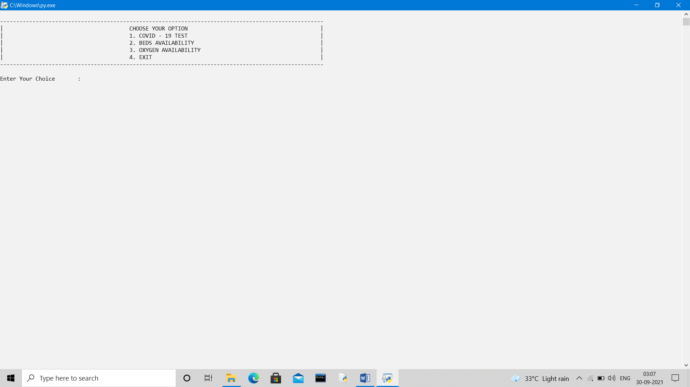

**IF OPTION-1 IS CHOOSED –“COVID-19 TEST”**

**OUTPUT-POSITIVE TEST SHOWN**

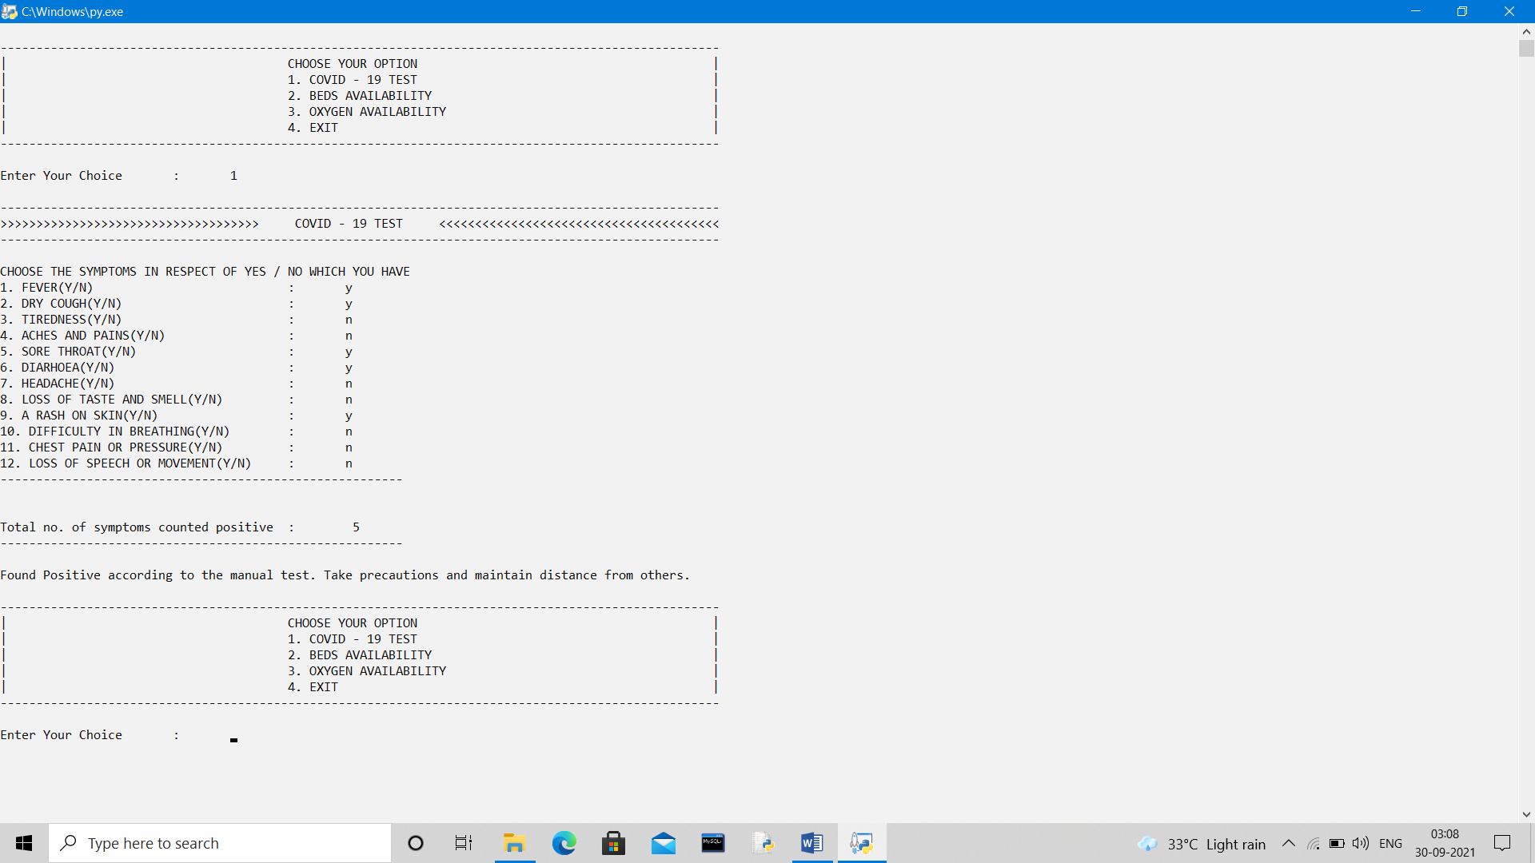

**IF OPTION-1 IS CHOOSED –“COVID-19 TEST”**

**OUTPUT-POSITIVE TEST MILDLY EFFECTED SHOWN**

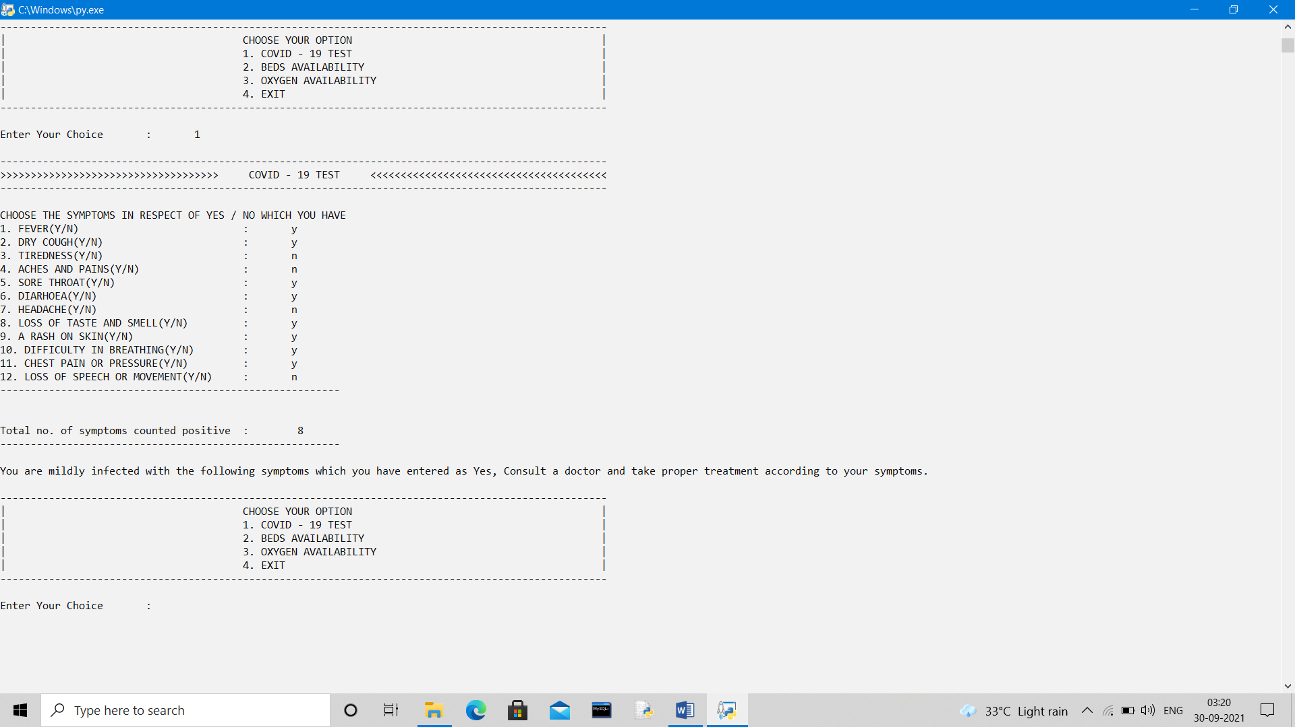

**IF OPTION-1 IS CHOOSED –“COVID-19 TEST”**

**OUTPUT-POSITIVE TEST HIGHLY EFFECTED SHOWN**

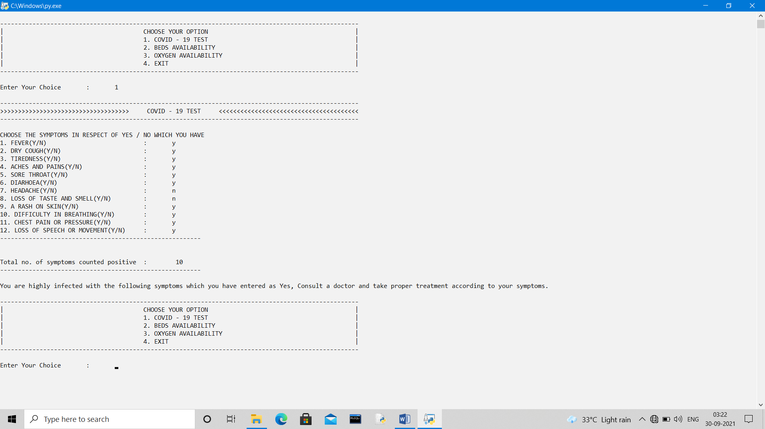

**IF OPTION-2 IS CHOOSED –“BEDS AVAILABILITY”**

**OUTPUT- OPTION-1 ZONE WISE SELECTION FOR SEARCHING OF DATA CHOOSED**

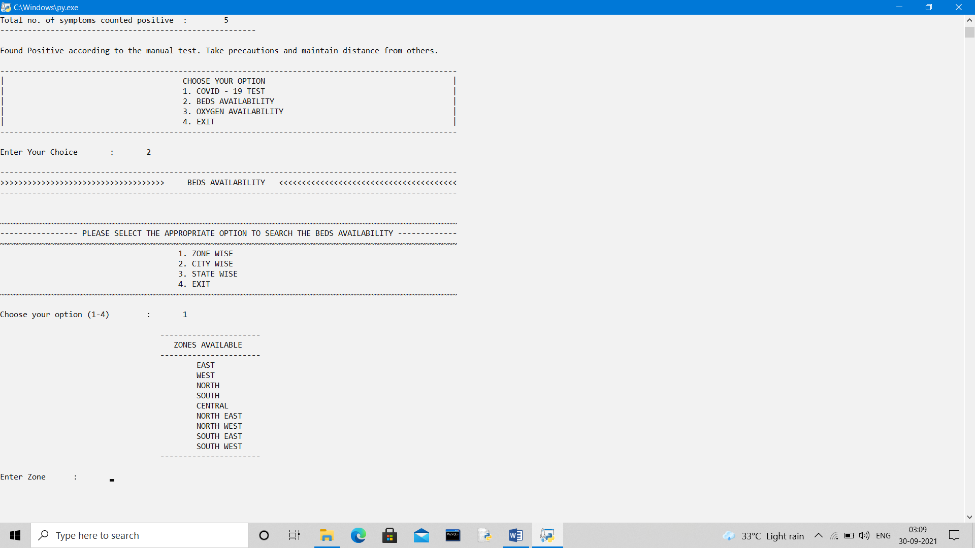

**ZONE WISE DATA SHOWN FOR EAST ZONE**

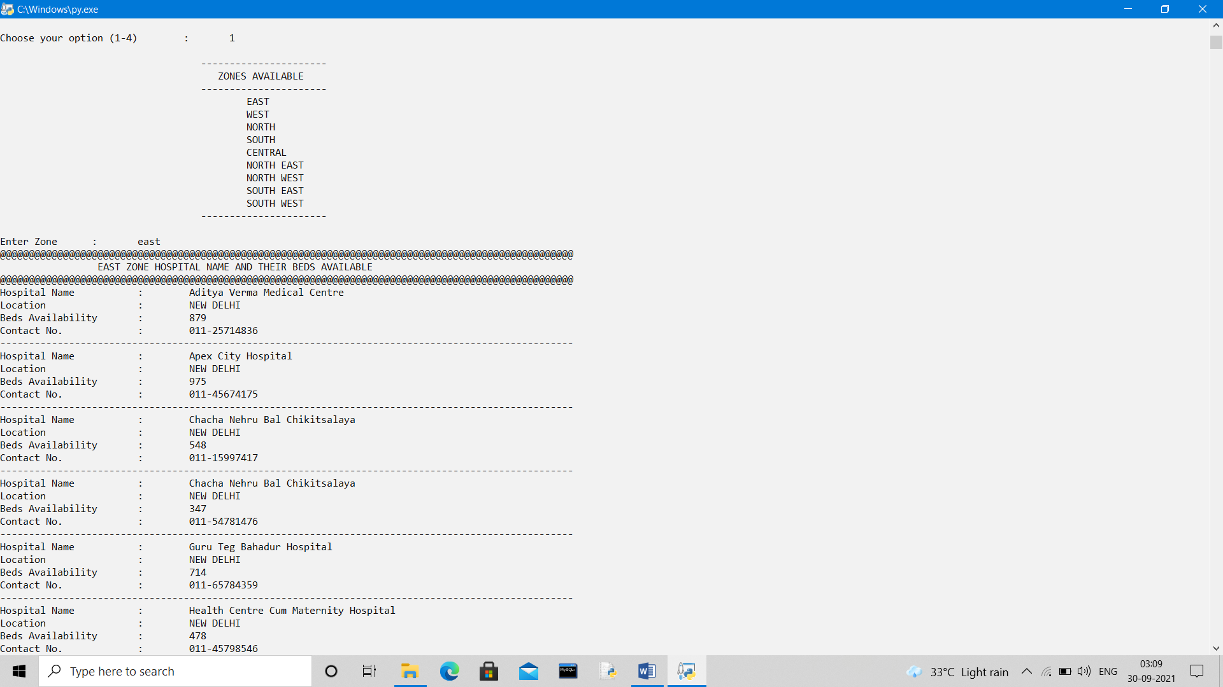

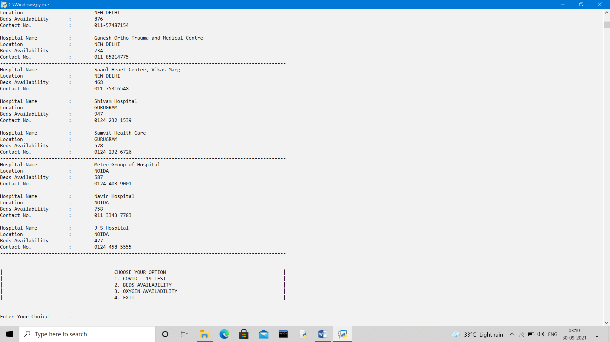

**IF OPTION-2 IS CHOOSED –“BEDS AVAILABILITY”**

**OUTPUT- OPTION-2 CITY WISE SELECTION FOR SEARCHING OF DATA CHOOSED**

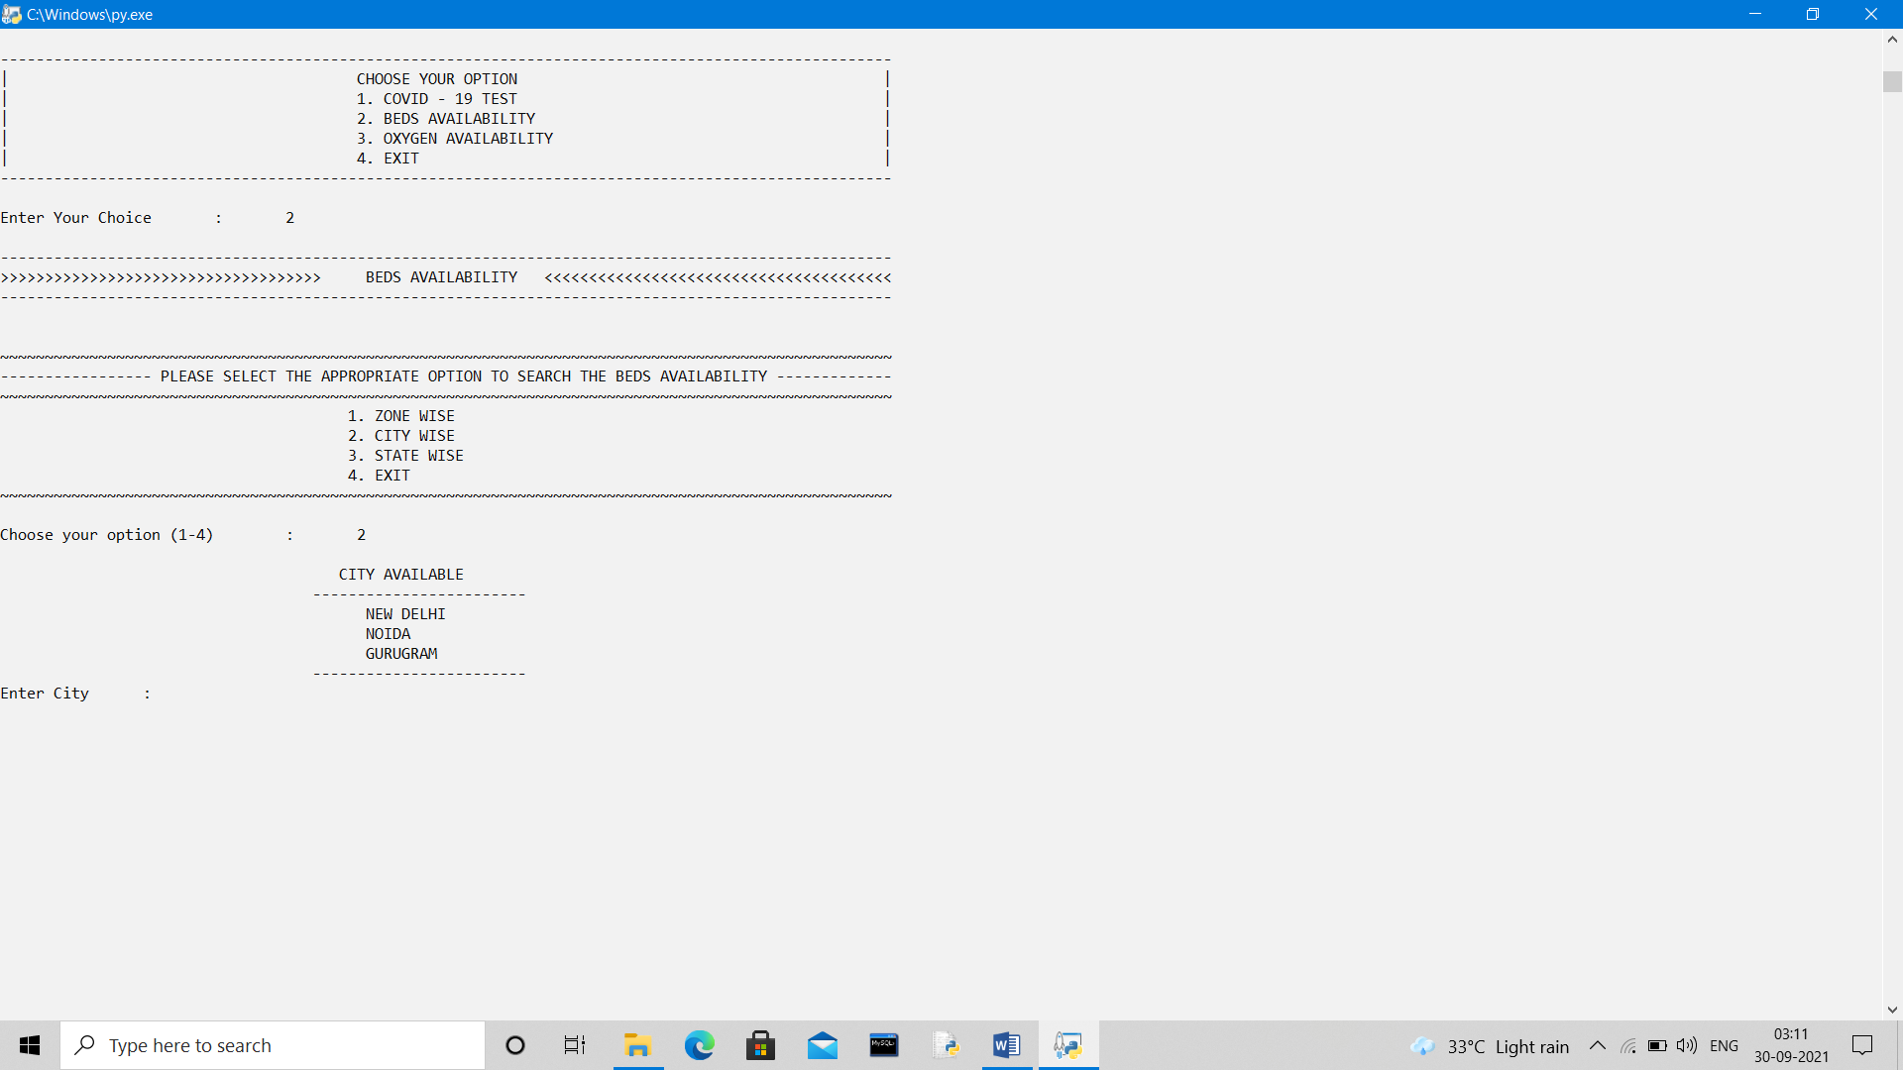

**CITY WISE DATA SHOWN FOR EAST ZONE**

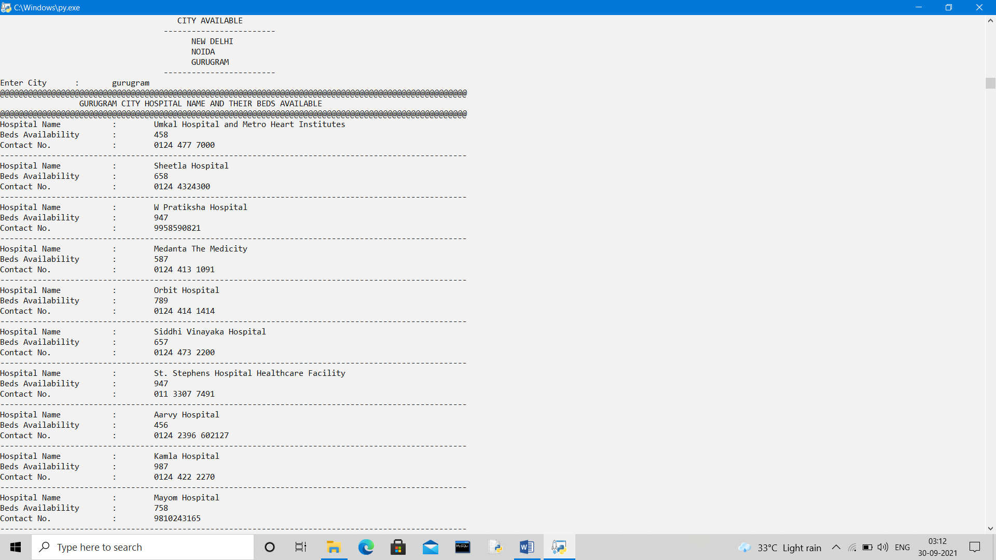

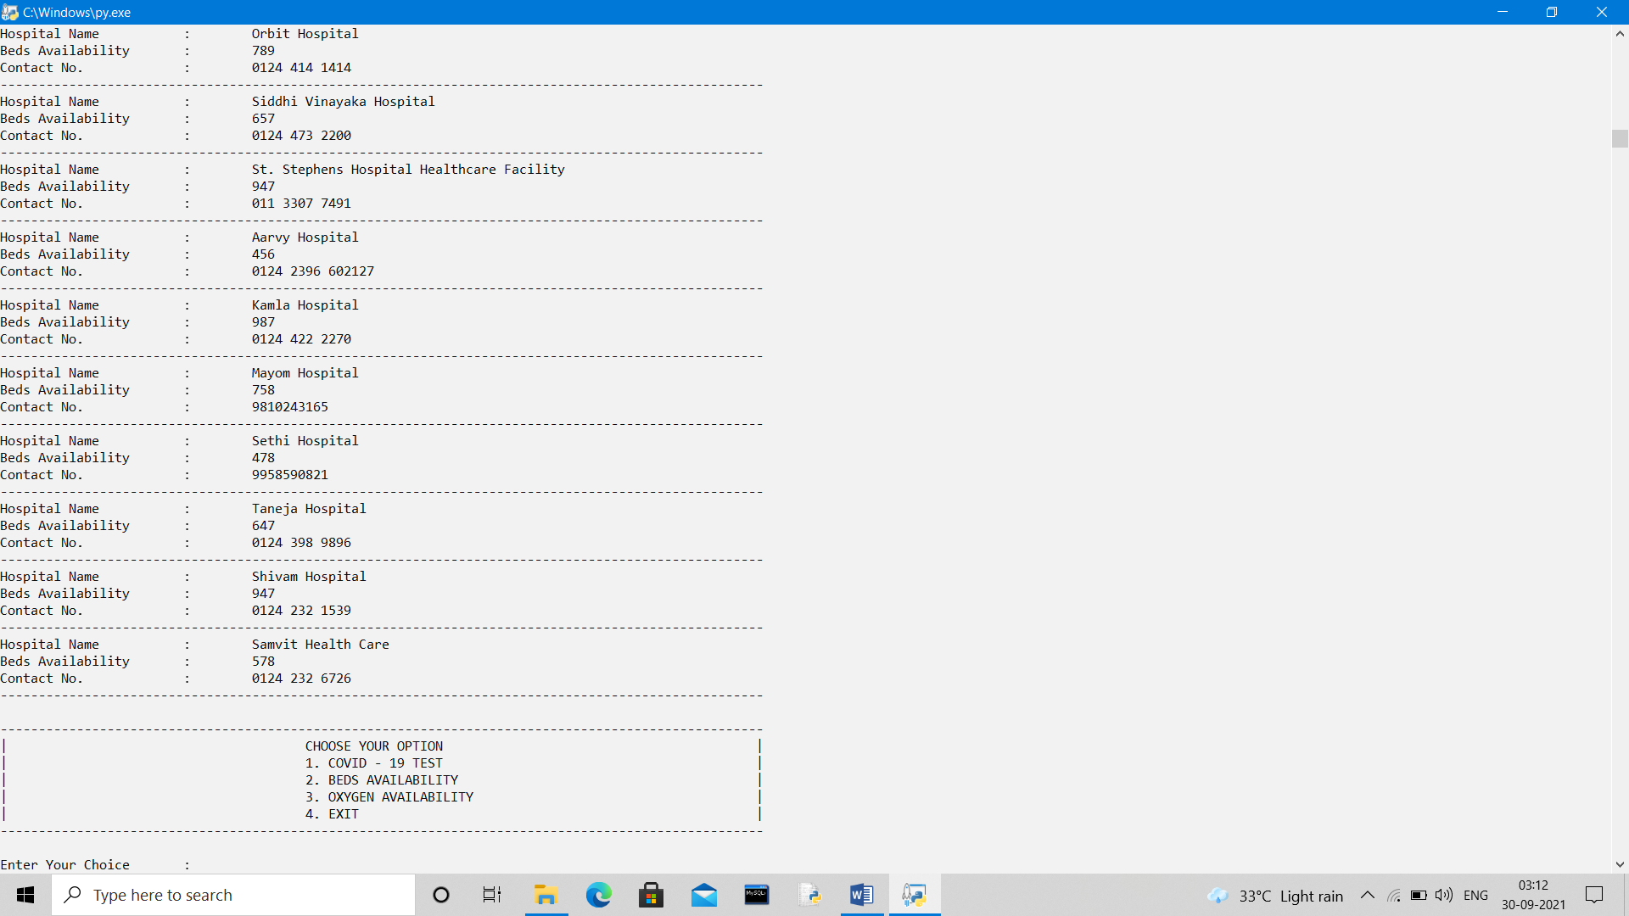

**IF OPTION-2 IS CHOOSED –“BEDS AVAILABILITY”**

**OUTPUT- OPTION-3 STATE WISE SELECTION FOR SEARCHING OF DATA CHOOSED**

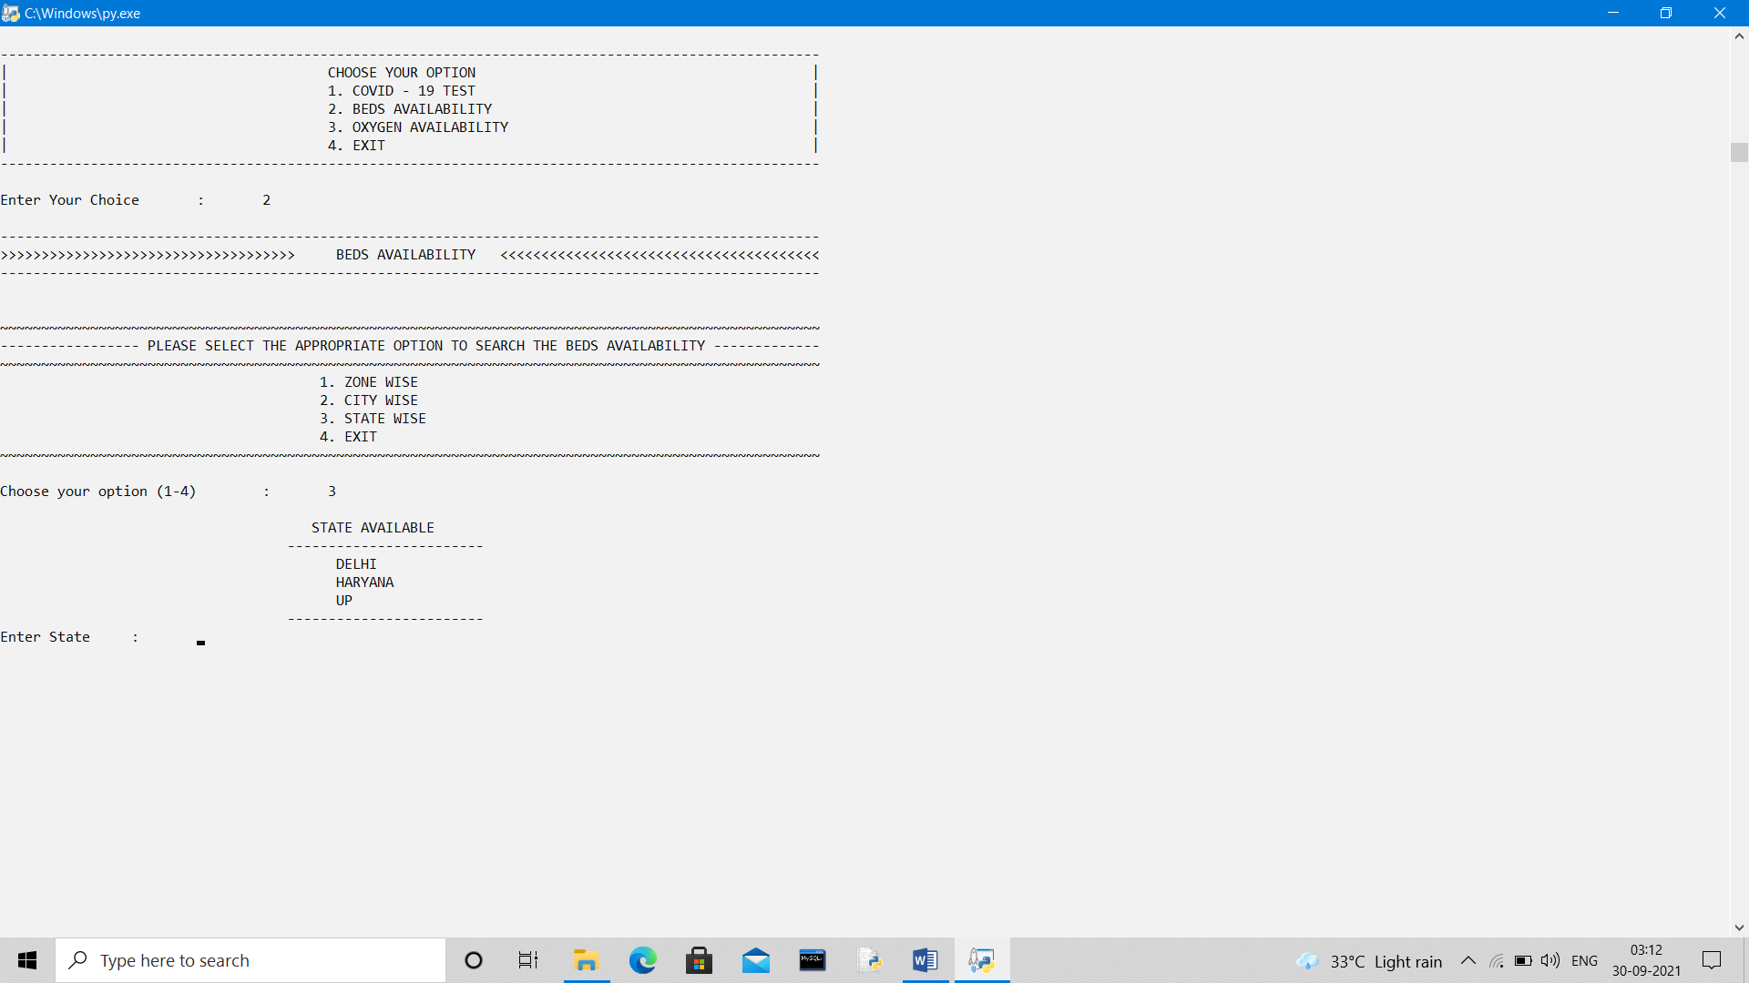

**STATE WISE DATA SHOWN FOR EAST ZONE**

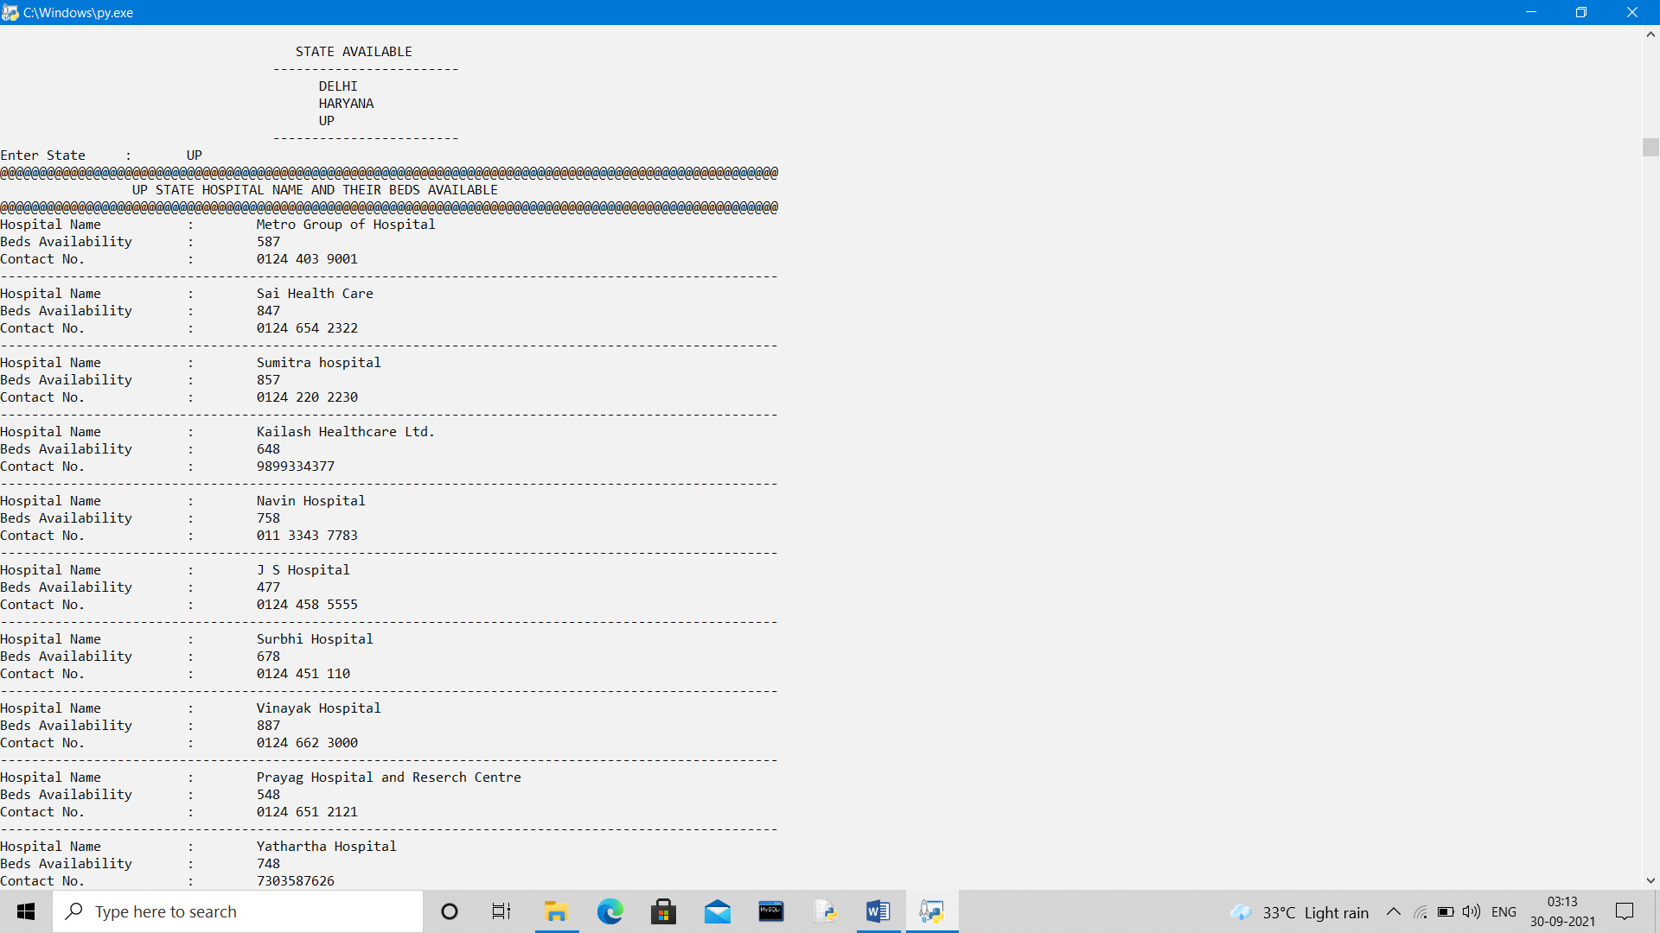

**IF OPTION-3 IS CHOOSED –“OXYGEN AVAILABILITY”**

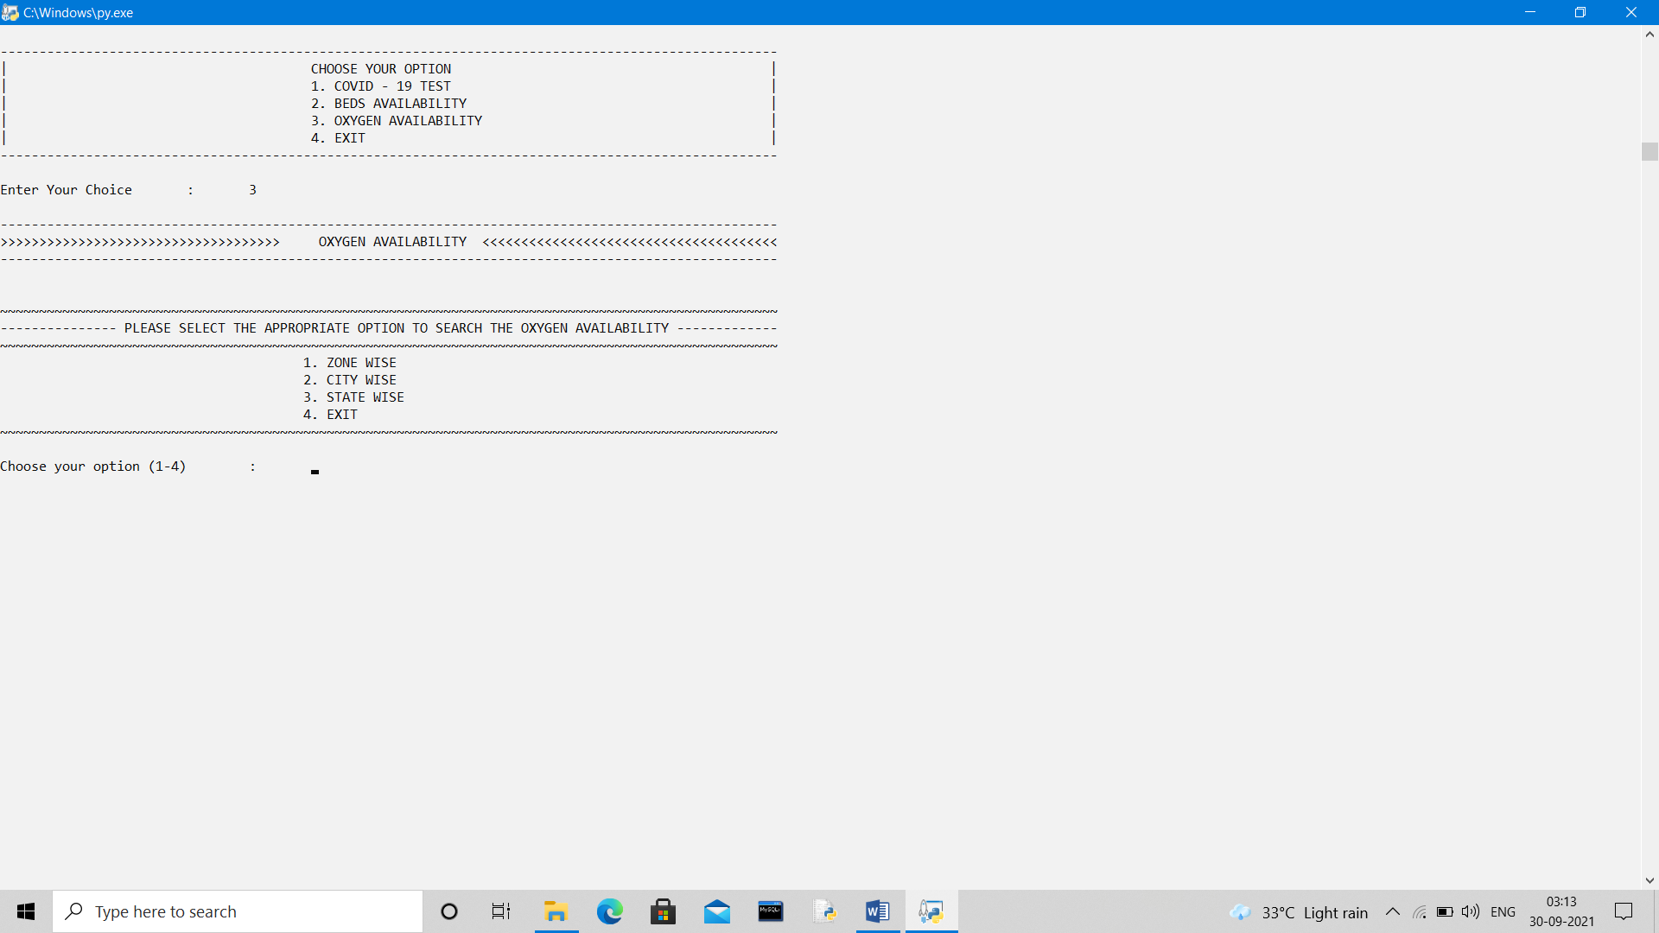

**IF OPTION-3 IS CHOOSED –“OXYGEN AVAILABILITY”**

**OUTPUT- OPTION-1 ZONE WISE SELECTION FOR SEARCHING OF DATA CHOOSED**

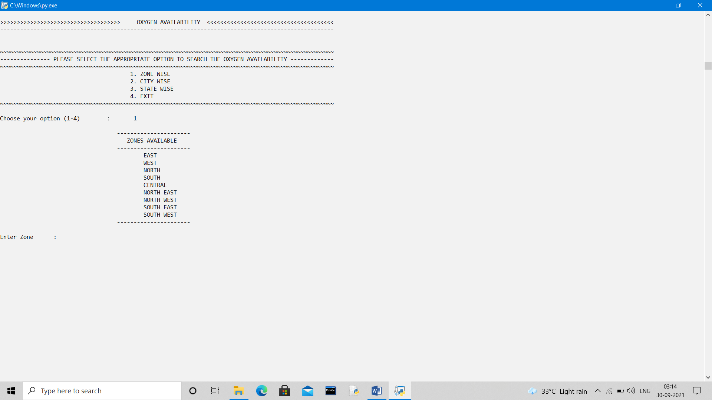

**STATE WISE DATA SHOWN FOR EAST ZONE**

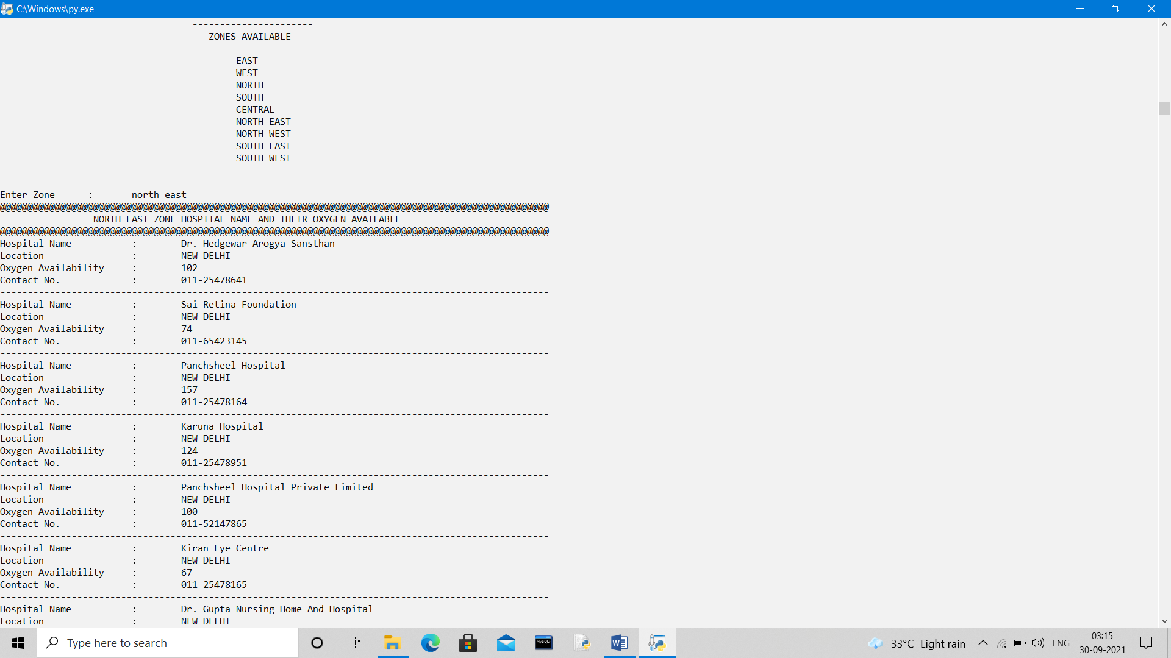

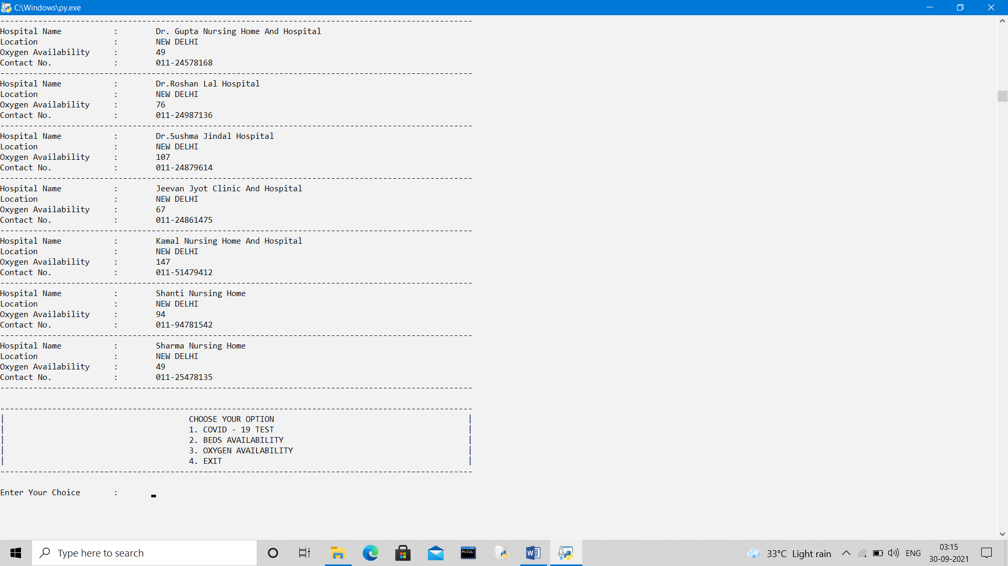

**IF OPTION-3 IS CHOOSED –“OXYGEN AVAILABILITY”**

**OUTPUT- OPTION-2 CITY WISE SELECTION FOR SEARCHING OF DATA CHOOSED**

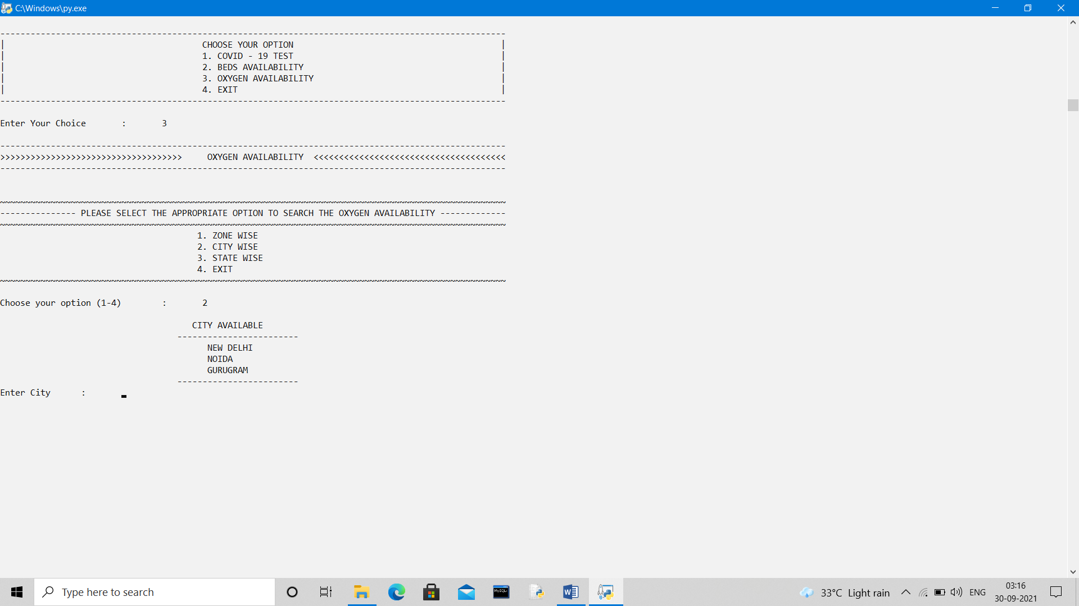

**CITY WISE DATA SHOWN FOR EAST ZONE**

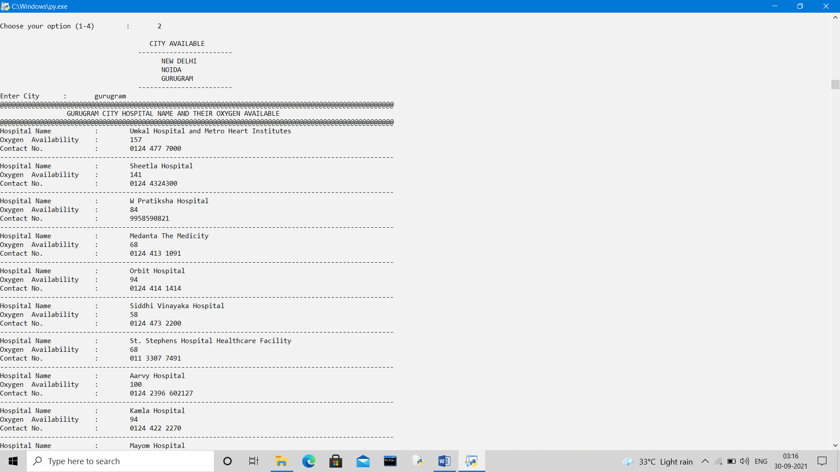

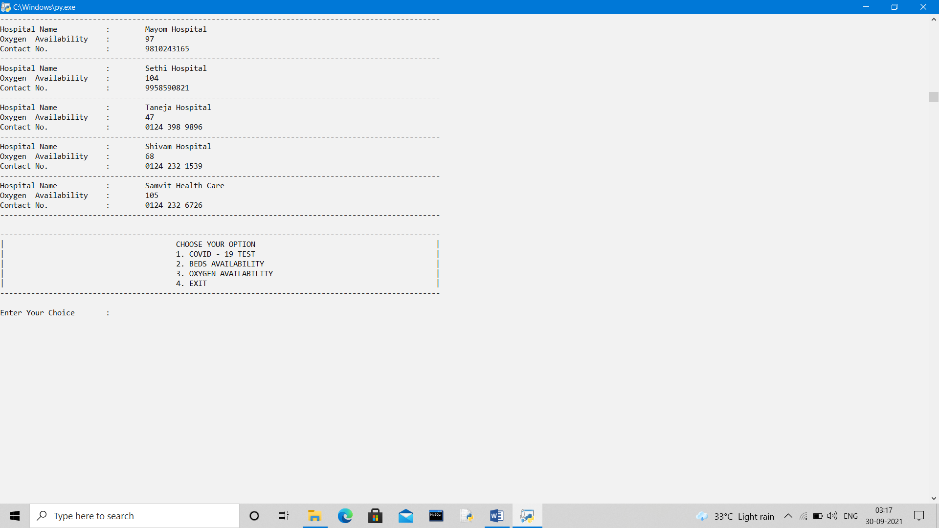

**IF OPTION-3 IS CHOOSED –“OXYGEN AVAILABILITY”**

**OUTPUT- OPTION-3 STATE WISE SELECTION FOR SEARCHING OF DATA CHOOSED**

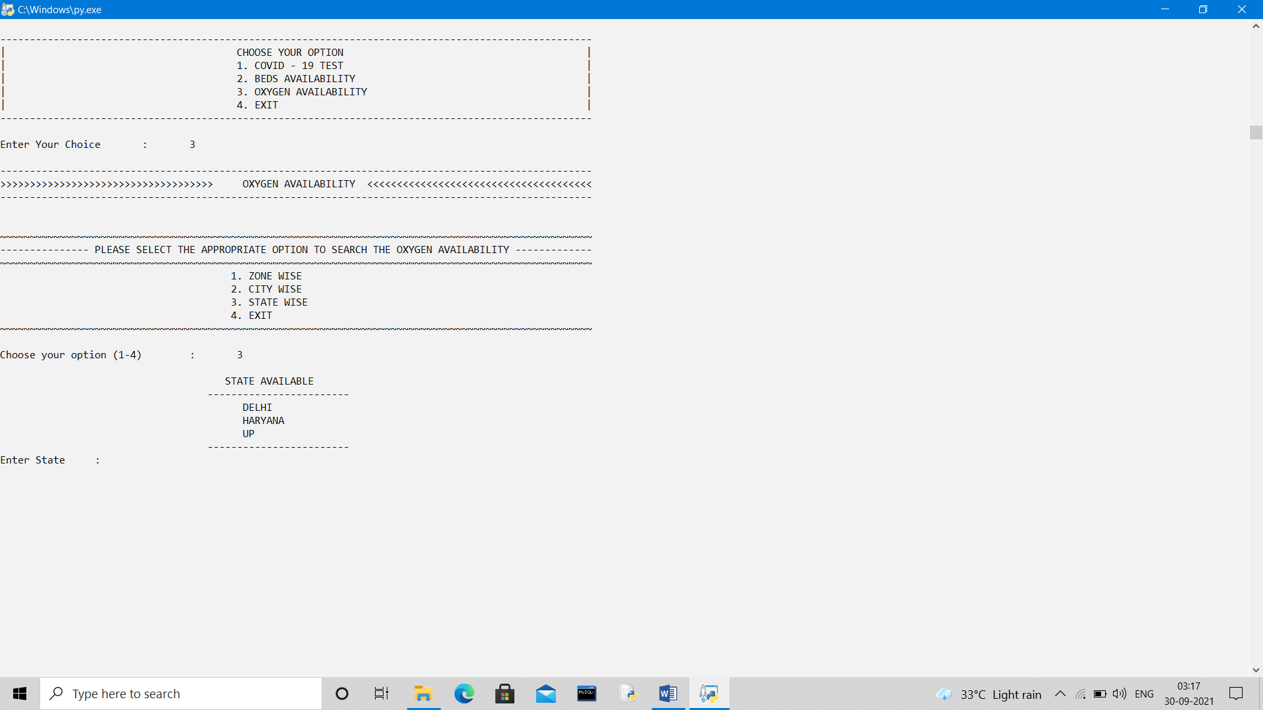

**STATE WISE DATA SHOWN FOR EAST ZONE**

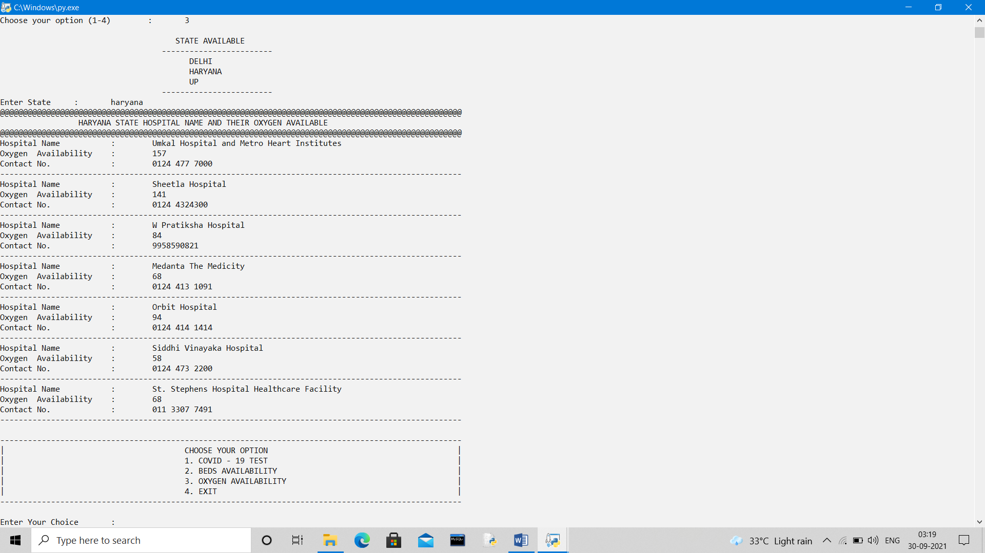

***AREAS OF IMPROVEMENT, FUTURE SCOPE AND FURTHER ENHANCEMENTS***

1. Currently this software which we have created is in offline mode, but in future we try to make it online.
2. In this software we haven’t give a particular location to choose hospital for the Oxygen and Beds availability.
3. In future we will give the option to the hospital to daily update the Beds and Oxygen availability.

.



***CONCLUSION***

**While making the project on “COVID-19 24X7 HELPLINE SYSTEM” it gives a better experience. We are doing the manual test of the patient that was the most important part of the project, firstly patient insert their basic information and other formalities.**

**Some important things that I learned include designing a good program architecture and converting real life situations into an efficient code, and how to write an good looking easily readable and understandable as well as time and memory efficient code. It helps me in future for making a different project of computer science.**

**Hope it helps someone**



***BIBLIOGRAPHY AND REFERENCES***



* COMPUTER SCIENCE WITH PYTHON – SUMITA ARORA
* COMPUTER SCIENCE WITH PYTHON – PREETI ARORA
* [WWW.W3SHOOLS.COM](http://WWW.W3SHOOLS.COM)
* [WWW.PYTHON.ORG](http://WWW.PYTHON.ORG)

– SOFTWARE INSTALLATION